

**Pupil star of the week**

LL: AM: Evelyn and Eleanor- For settling into a new routine and joining in at carpet times

LL: PM: Noah- For being enthusiastic with his singing and trying hard with number

CC: AM: Harper- For her positive attitude towards learning and developing her perseverance skills.

CC: PM: Amayah- For always being kind, thoughtful and a good friend to all

BB:  Emilia-Rose for fantastic work in school and for all the amazing work you did at home!

SS 1: Payton - For working hard at phonics and reading.

SS 1/2: Isla Laws - For persevering and always trying her best in all her work.

DD 2:  Summer Cooper- For going above and beyond with her home learning and for joining in with every lesson!

SS 3/4: Zayn for always showing that he cares and being enthusiastic and inquisitive.

BB 3/4: Alleyah for settling in so well to our school and putting her best effort into everything. She has had a positive attitude to learning and made super behaviour choices. Well done Alleyah.

OO 5: Collins for always being himself and making me smile each and everyday! Your dance moves alone deserve star of the week!

SS 5: Sachin Arokiyaraj for his great score in his Math test and his continuous improvement in English. Very proud young man!

LL 6: Derell - for being an expert learner, who challenges himself to improve in a calm and studious manner.

MM 6: Emaan - For always being herself and showing that she cares. Emaan is extremely thoughtful of other people's feelings. Emaan is also becoming and expert and knowledgeable learner especially in reading.

**Important Notices**

1. Remember to keep helping us with social distancing. Cases of Coronavirus are rising and therefore we all have a duty of care to each other to social distance.
2. To help us we would ask that you try and wear a mask to school and on the way home as this will help to support our community
3. Remember the government rules around maintainly bubbles are very clear-you should continue to maintain social distancing with anyone you do not live with.
4. Thank you for your home learning responses- we have looked at these and are trying to prepare to help you if your child has to learn at home.
5. Remember we have our new 5 ways of being which are:
6. ***Always be yourself***
7. ***Show that you care***
8. ***Be a knowledgeable and expert learner***
9. ***Be confident communicator***
10. ***Contribute to your community***

      6. Our Golden Book winners are filling up fast and we had another 30 children in       Golden book this week. Remember **every Monday** each class teacher also announces 2 children who will have hot chocolate for working hard last week #hotchocolatemonday

      7. **Reading**- it is vital you read at home with your child as much as possible-**every day** if you can. We have some great books that we send home too.

**What we’ve done this week**

Lively Ladybirds: This week we have been working on using our words to communicate how we are feeling

Curious Caterpillars: This week have been looking at pictures of our families at home. It has been lovely to listen to the children speak with such confidence

Brilliant Butterflies: This week we have been practicing our listening skills. We have played lots of games to help us with this. We really enjoyed some of our circle times!

Swooping Starlings: This week we have had to adapt to a different way of working. The children and parents have been brilliant and there has already been some great learning. Well done everyone.

Daring Ducklings:    This week we have been writing about our non-chronological reports about the sea animals which we have learnt!

Stupendous Squirrels: This week we had a fantastic hook day to start our new topic all about the Stone Age. We have also been lucky enough to have Mr Bleazard working with us remotely to teach us computing.

Blissful Badgers: We had our Stone Age hook day on Monday, so we enjoyed a visit from Tempus Fugit, we pretended to be archaeologists and dug up artefacts, and we did Forest schools with Mr O’Brien. It was a fabulous day!

Omniscient Otters: I have really enjoyed seeing my class still enjoy school life in what had been a trickier week. They have continued to work hard and still get some fun in which has been lovely to see!

Super Seals: Great week! It's a pleasure teaching this class and I hope their attitude to everything never changes. Enjoy your weekend!

Leaping Lions: In Year 6, we started to research the Geography of Antarctica, and created some impressive artwork, using wax crayons and watercolours.

Magnificent Monkeys: This week, we have been using a range of sources to locate Antarctica and identify the physical features of it. Comparing the landscape with other continents which we have studied.

**Head Teacher’s comment**

I have really enjoyed seeing all the amazing work this week and I have been so impressed by all the stories the pupils have written. My top 3 moments this week are:

1. Taking Jasper for a walk with Year 6-thank you Maisie-Leigh
2. Collins singing to me in the dinner queue
3. Seeing Joey use his tools in his Forest schools session.

I would like to thank all the staff in what has been a challenging week- they have been amazing. A stand out moment was when everyone supported and helped the team on Monday and Wednesday- I know it has been hard and you have done an amazing job.

The pupils had some great online learning help in Mrs Harrison’s class from Tim Bleazard as we try and support you in online learning as best we can. We even had one pupils logging in from home for all her lessons this week while she was at home!

Another amazing week both indoors and out! Have a great weekend everyone!

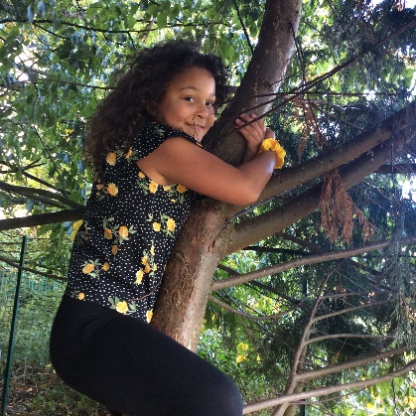

**Photos from this week**

