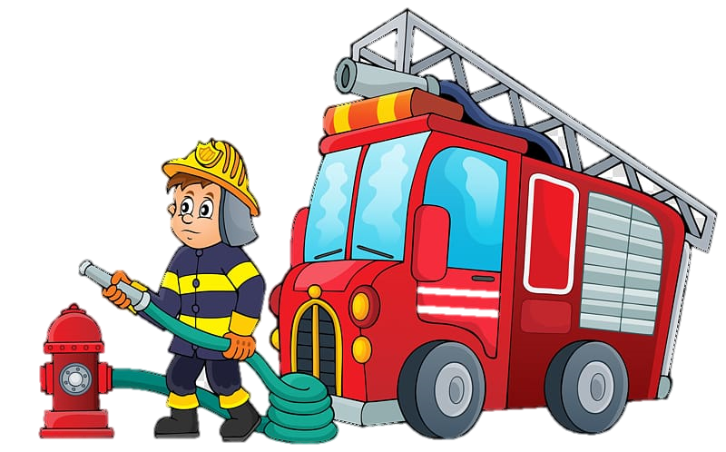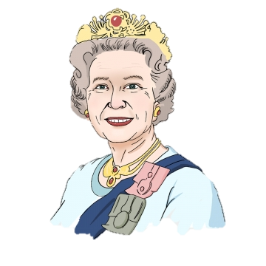

Grand Finale

Royal tea party.

Physical Development

* Understanding the need for a healthy and varied diet.
* To understand how to move and store equipment safely.
* Practice our pencil grip
* To travel with confidence. Moving in different ways.

Understanding the World

* To understand the changes of the seasons
* To know the effect weather has on things eg water freezing.
* To use software for a purpose.
* To recognise a powerful person and their role.

Personal, Social and Emotional Development

* To build good relationships with peers and staff.
* To learn how to share with our friends.
* To complete task independently.
* To show you care for others.

Communication and language

* To listen to others and respond appropriately.
* To use questions to clarify understanding.
* To retell events in order.

Reception Curriculum Overview Autumn

Topic- Helping hands

Key theme- Community

Key Question- What are our classroom rules?

Expressive Media and Materials

* To explore use colour for a purpose.
* To join materials together using different techniques.
* To sing familiar songs.

**Literacy**

**Reading:**

* **To begin to recognise set 1 sounds.**
* **To recognise taught red words**
* **To blend CVC words**

**Writing:**

* **To write own name independently.**
* **To form letters correctly and the same size.**
* **To write CVC words.**
* **Retell familiar stories**

Maths

* To find one more or one less of a given number.
* To recognise numbers to 10 and match quantities to the numbers.
* To recognise and 2D shapes and their properties
* To order objects by their height, weight or length.
* To sequence every day events.