Wednesday 25.11.20
Maths
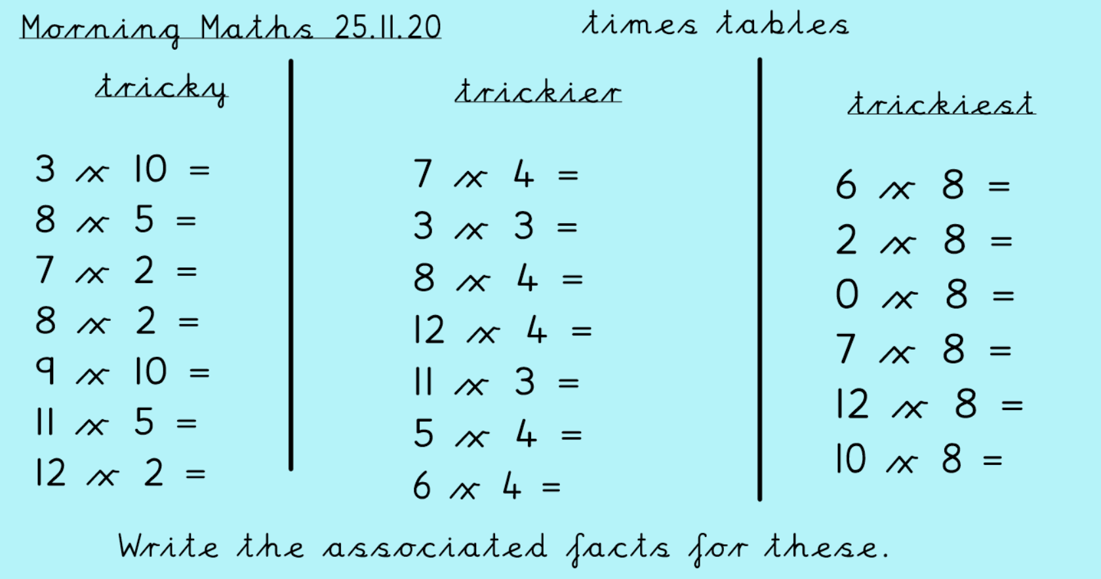
Use BBC supermovers and practice your times tables.
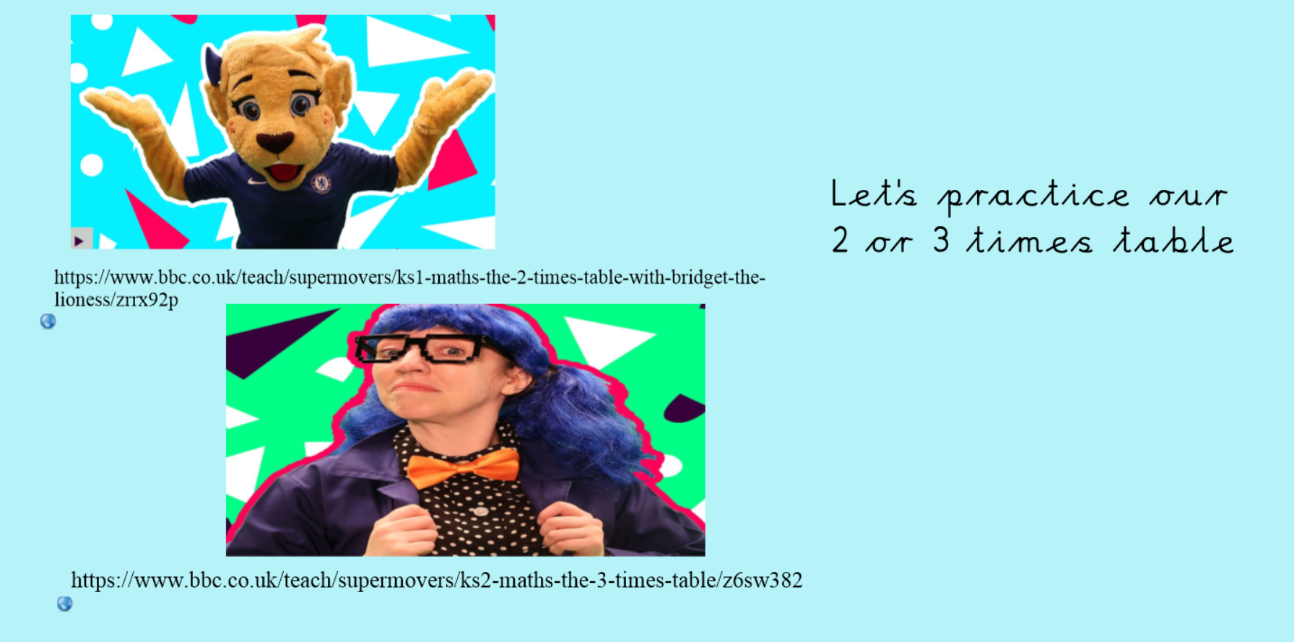
https://www.bbc.co.uk/teach/supermovers/times-table-collection/z4vv6v4

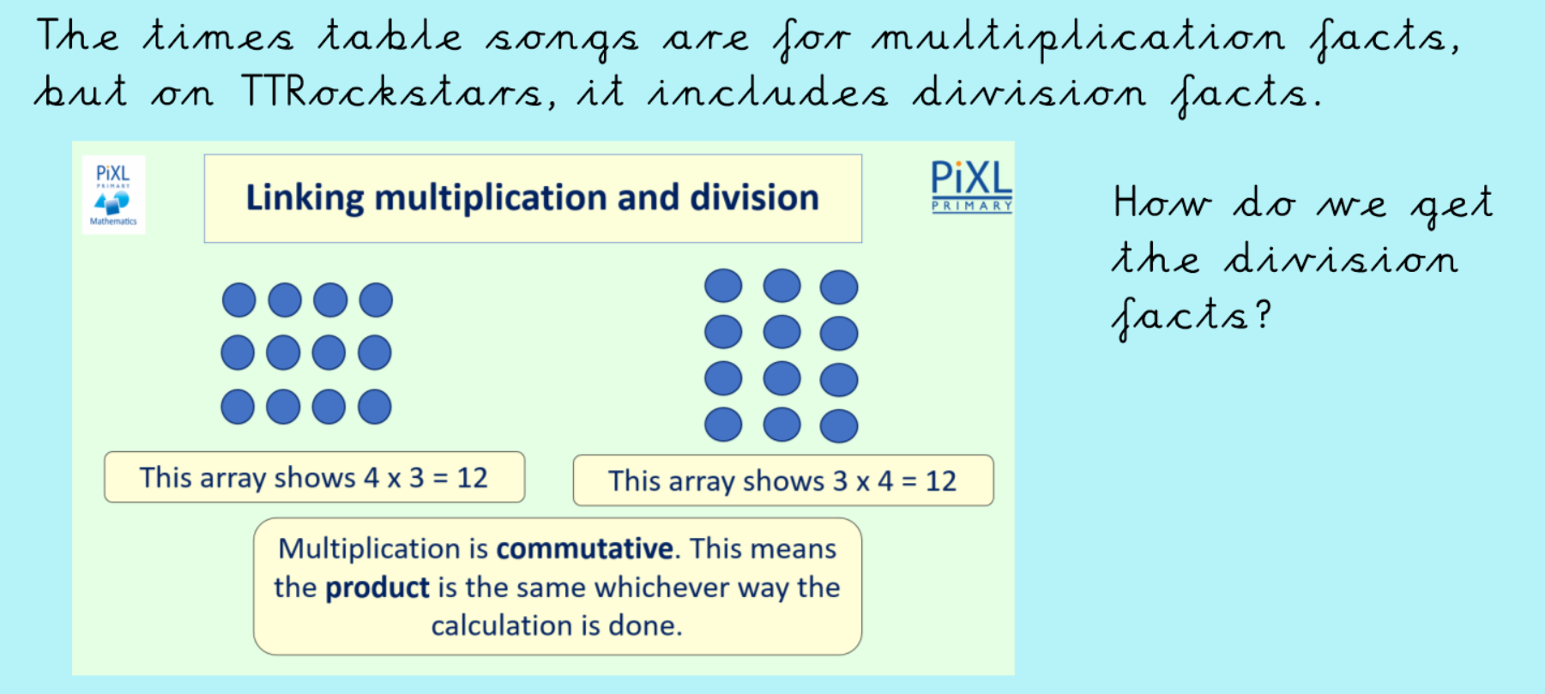
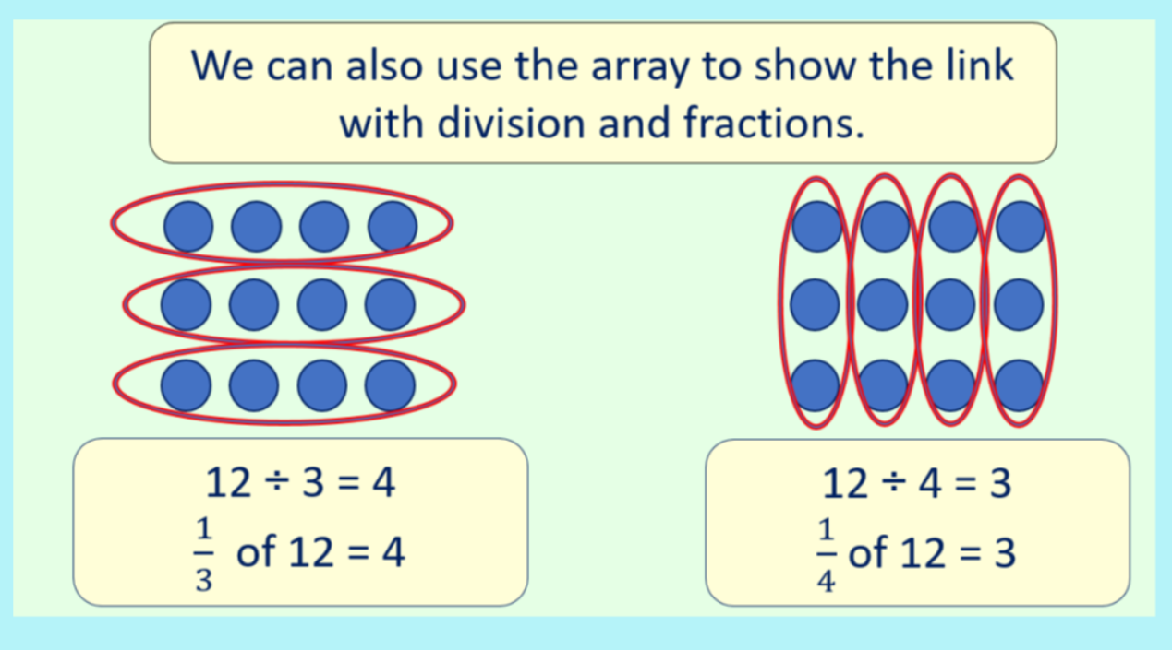
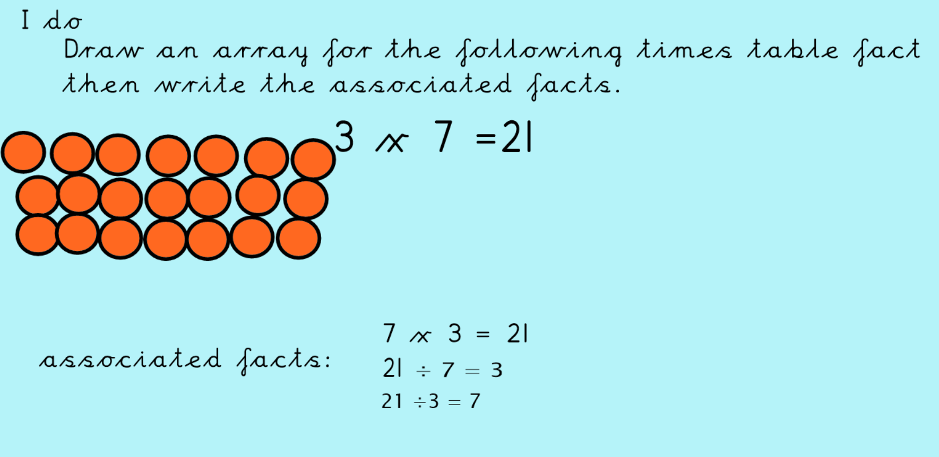
Now have a go at either the Tricky, Tricker or Trickiest activity

