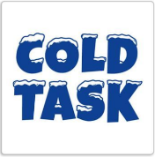
Cold writing task: Imagine you are the boy from Stone Age Boy and write a diary about the adventure you have had in the Stone Age.

Cold writing task: Imagine you are the boy from Stone Age Boy and write a diary about the adventure you have had in the Stone Age.

Cold writing task: Imagine you are the boy from Stone Age Boy and write a diary about the adventure you have had in the Stone Age.

Cold writing task: Imagine you are the boy from Stone Age Boy and write a diary about the adventure you have had in the Stone Age.

Cold writing task: Imagine you are the boy from Stone Age Boy and write a diary about the adventure you have had in the Stone Age.

Cold writing task: Imagine you are the boy from Stone Age Boy and write a diary about the adventure you have had in the Stone Age.

Cold writing task: Imagine you are the boy from Stone Age Boy and write a diary about the adventure you have had in the Stone Age.

Cold writing task: Imagine you are the boy from Stone Age Boy and write a diary about the adventure you have had in the Stone Age.

