LI: To write the multiplication facts associated with these arrays.
I will be successful if:
I can count the dots in each row to find one factor.
I can count the dots in each row to find another factor.
I can count all of the dots to find the product.

Write two multiplication facts for each array.
- 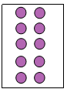 2. 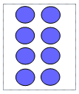 3. 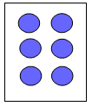
4. 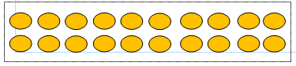

Draw the array for these multiplication facts. Work out the product.
5. 3 x 5 =
6. 2 x 5 =
7. 3 x 10 =

