LI: To know the vocabulary associated with multiplication and use it to write and say statements for the 3, 4 or 8 times table.
I will be successful if:
I can write tell me statements using factor, product and multiple.
I can use factor, product and multiple in oral statements about the 3, 4 or 8 times table.
I can recall facts for the 3,4 and 8 times tables.
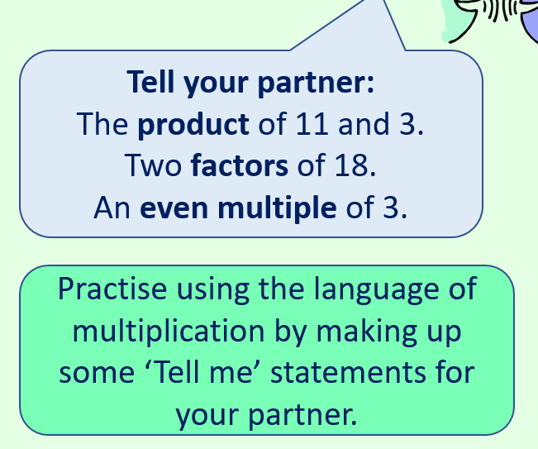
Write 5 sets of tell me statements and discuss them with a partner, using the correct vocabulary.

