Monday 23rd November
Reading
We are focussing on reading fluency today.
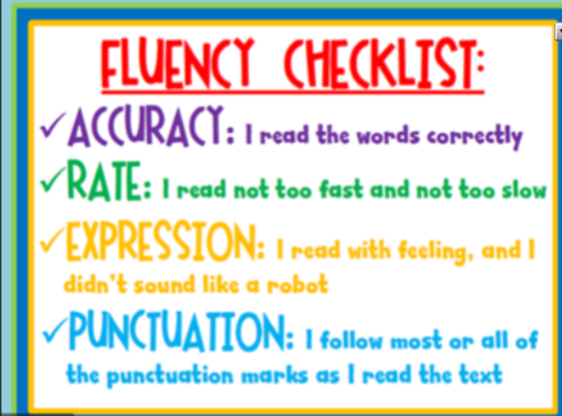
Ask an adult to read the text with you. Think about the expression you are using to read and when you would need to use different expressions.
Also pay attention to the punctuation. Make sure you stop at the full stops, change your intonation/ expression if you are asking a question and pause if there is an ellipsis (…) or a comma.

When you write your own portal story this week, you will need to use good description to make the reader have empathy with the characters. Which words, phrases or sentences could you magpie from The Wild Way home, that you could use in your story?

Copy 4 sentences that you would like to copy and use yourself. Tell us why you would like to use those sentences.

