You have planned your story at school but don’’t have the plan with you at home.

You can use this plan below or find the boxing up grid challenge to re plan your story.

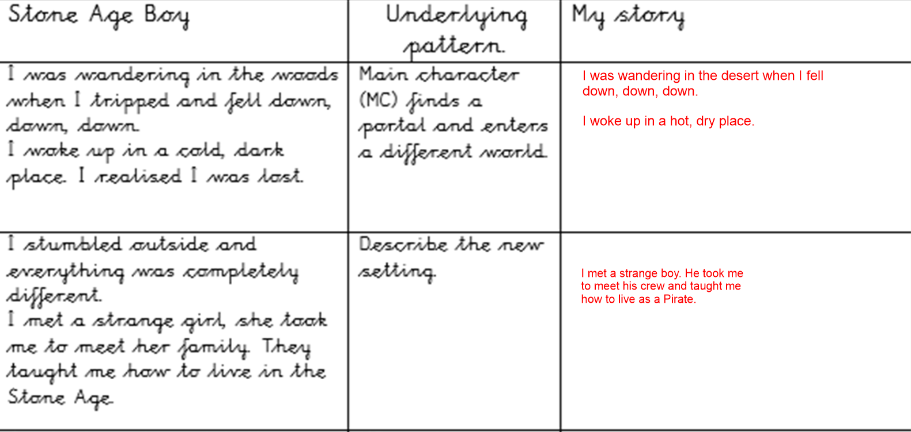
We are going to write the opening to the story.
We will use a range of fronted adverbials.
Use the following video clip to learn about what fronted adverbials are.

https://www.bbc.co.uk/bitesize/topics/zwwp8mn/articles/zp937p3#:~:text=A%20fronted%20adverbial%20is%20when,today'%20is%20a%20fronted%20adverbial.

