RE
Monday 23rd November
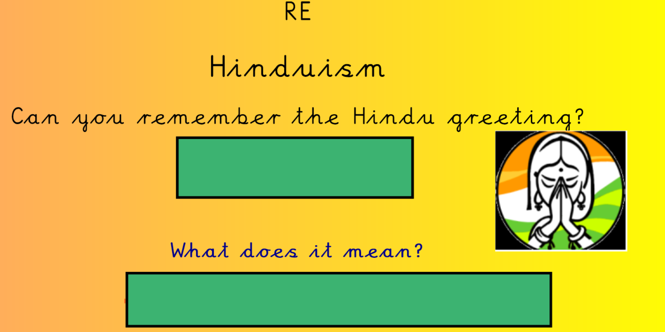
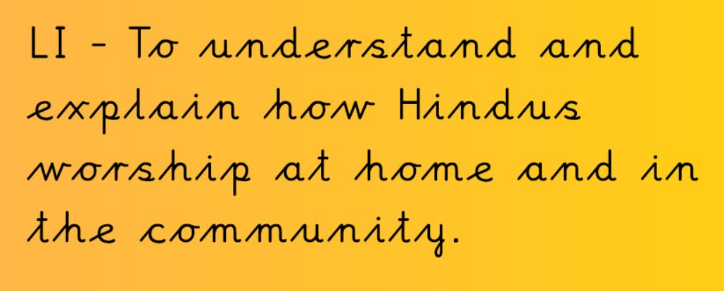
Let’s look at Hindu worship at home. Watch this video all about it.
https://www.bbc.com/bitesize/clips/zh2hyrd

What is worship like in the temple? Have a look at this video clip.

https://www.bbc.co.uk/teach/class-clips-video/religious-studies-ks2-my-life-my-religion-hinduism-inside-hindu-temple/zbf2t39
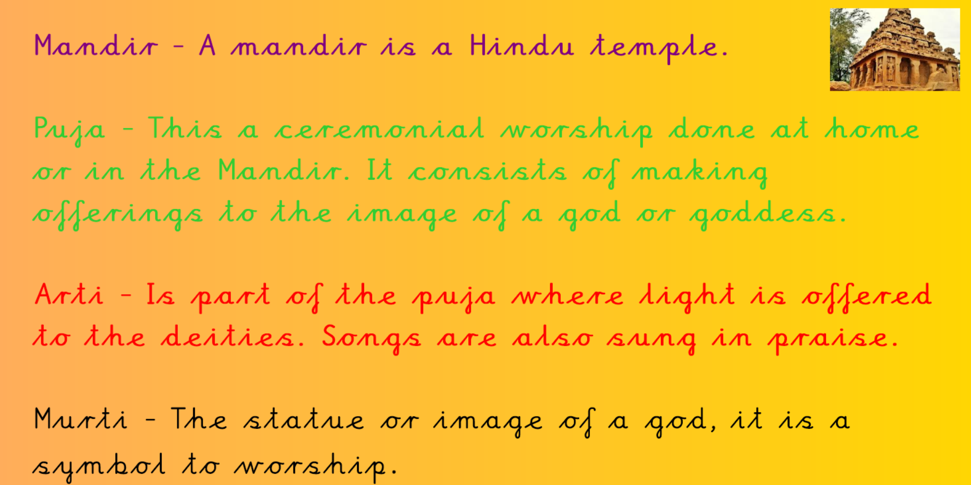
What’s the same and what’s different about the worship at home or at the Mandir?

