Science

Thursday 26th November

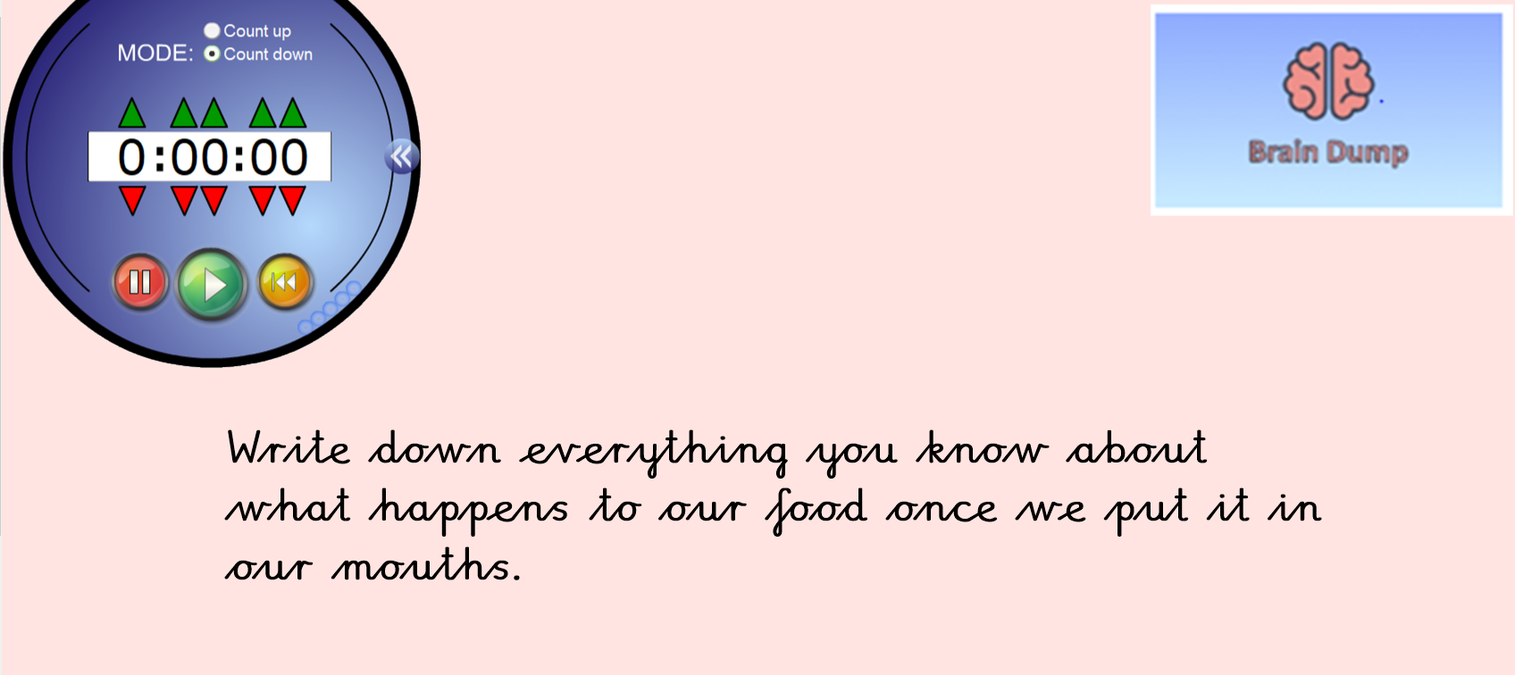

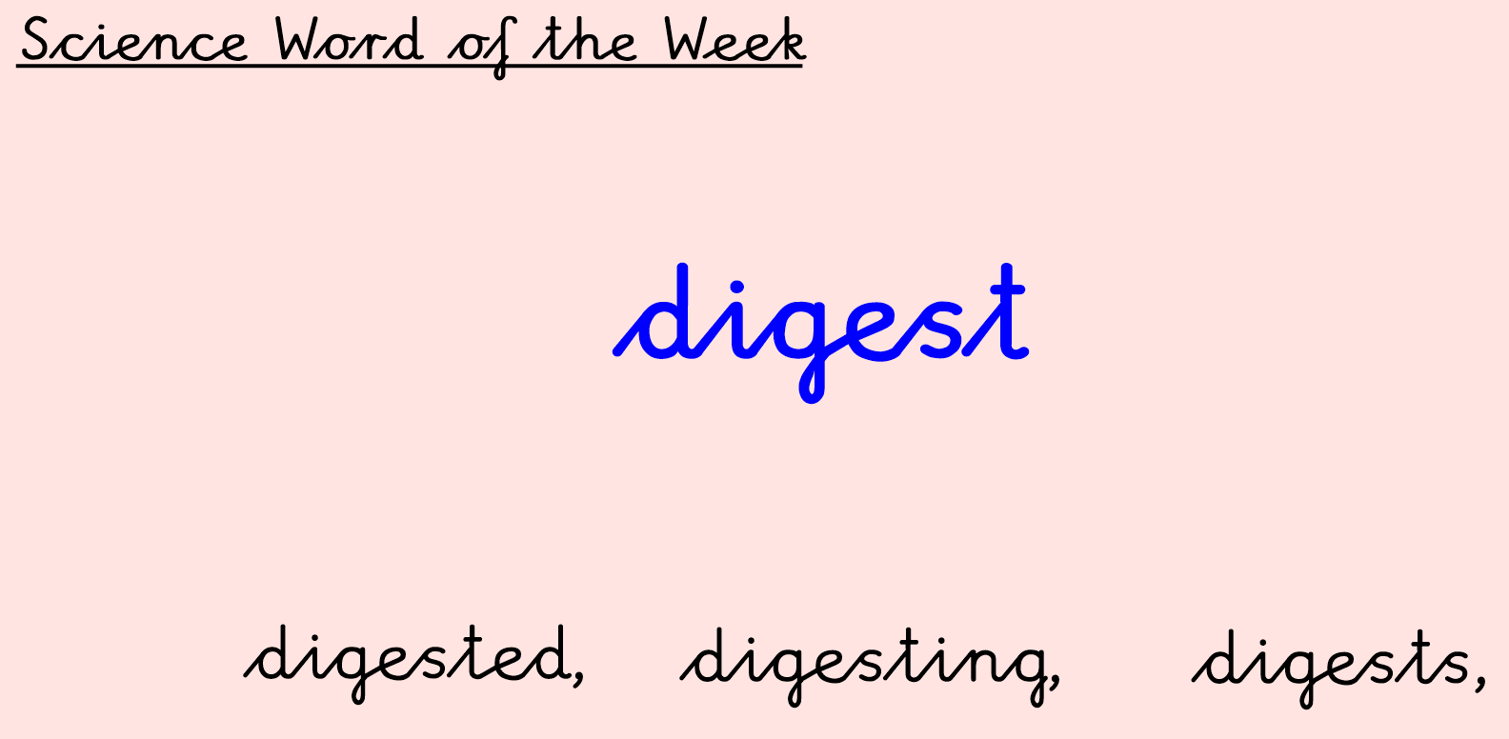

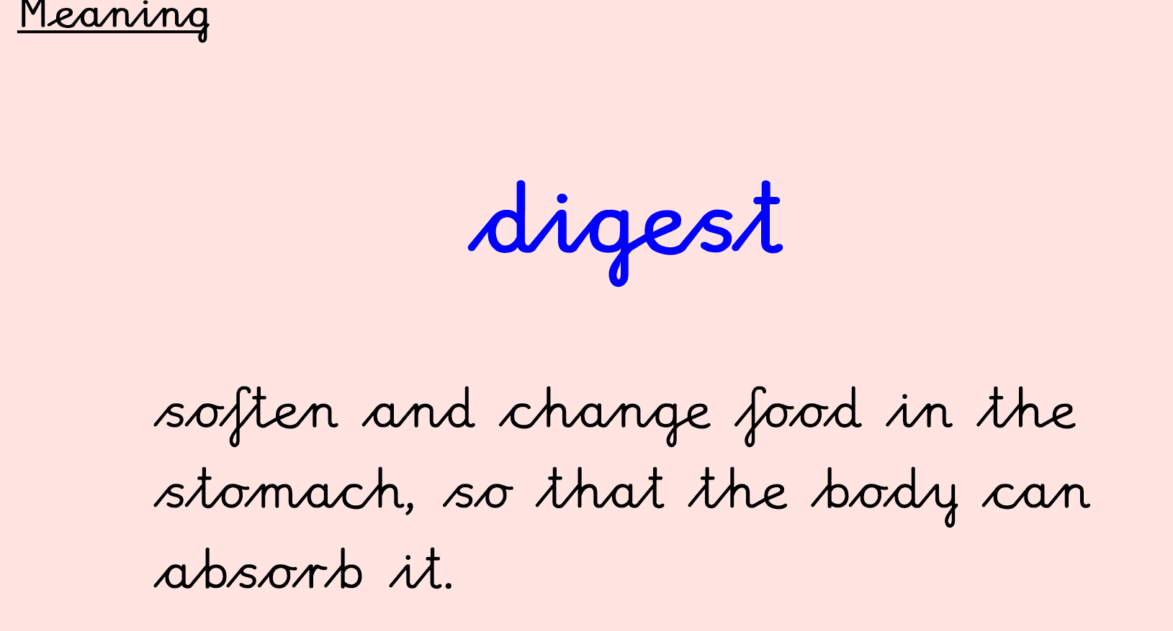





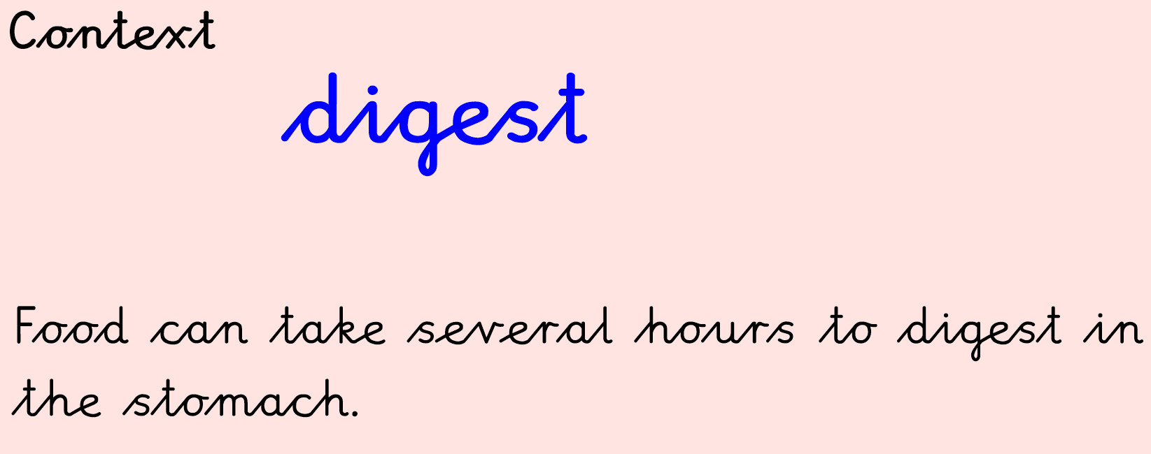

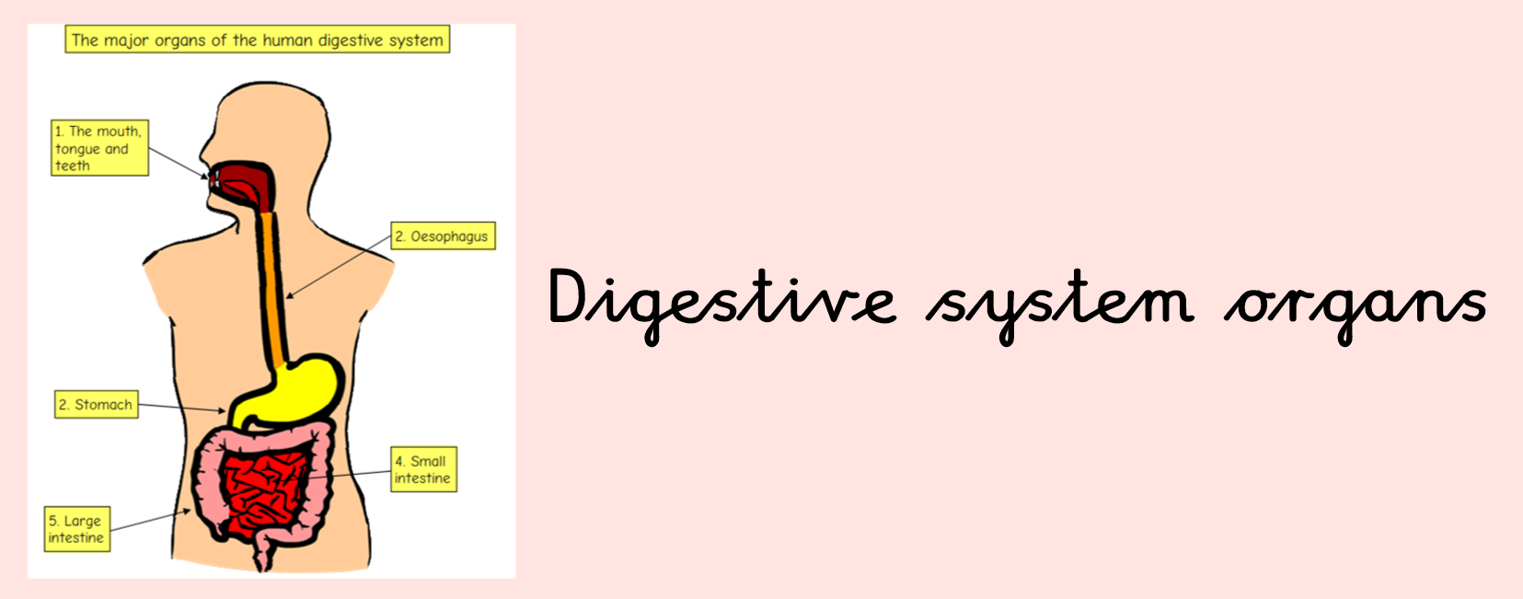

Have a look at this website link and learn all about the digestive system

[**https://www.bbc.co.uk/bitesize/topics/z27kng8/articles/z9wk7p3**](https://www.bbc.co.uk/bitesize/topics/z27kng8/articles/z9wk7p3)

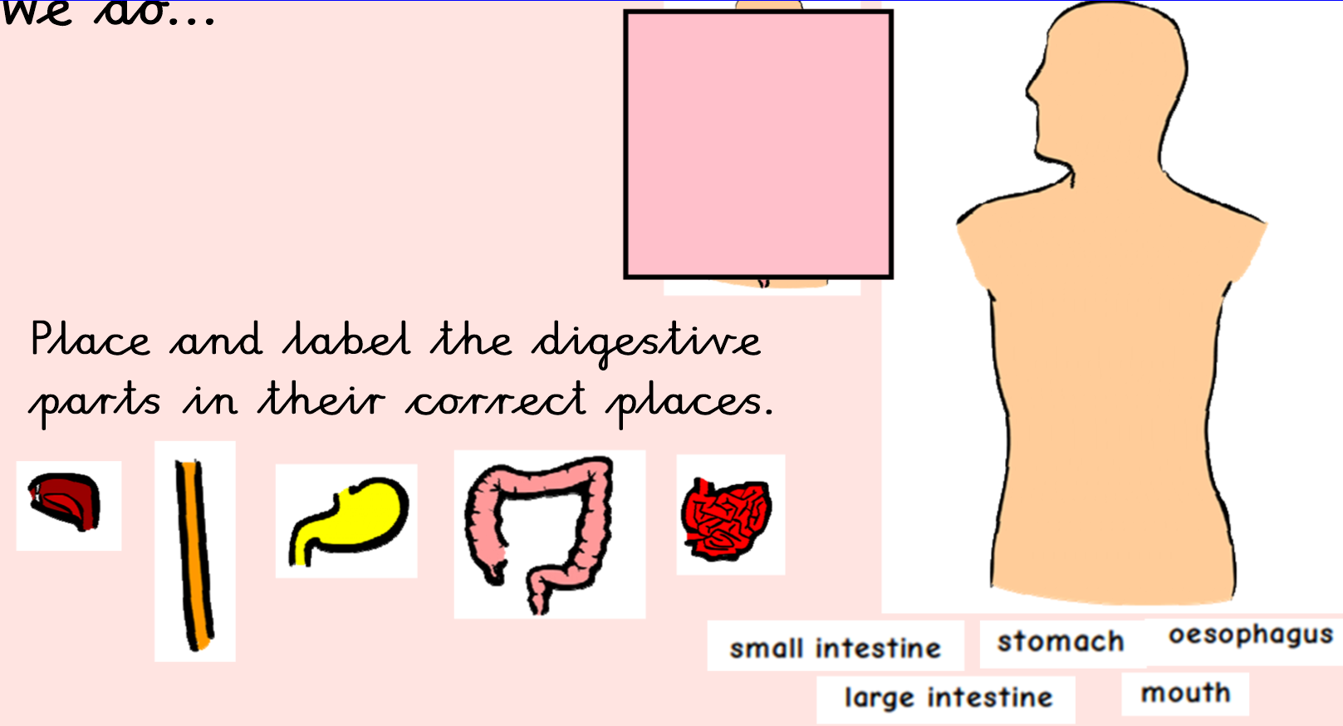

Draw and label the digestive system