SkaraBrae
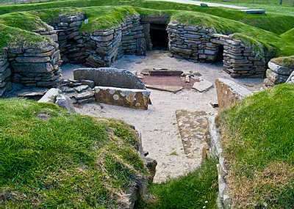

Re-cap
Quick write
what can you remember about Skara Brae?
Where is it?
What is it?
What are some of the physical and human features of it?

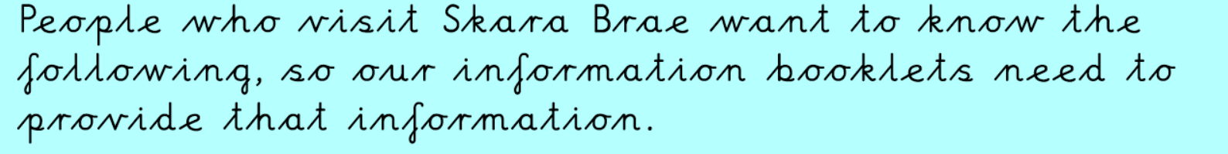
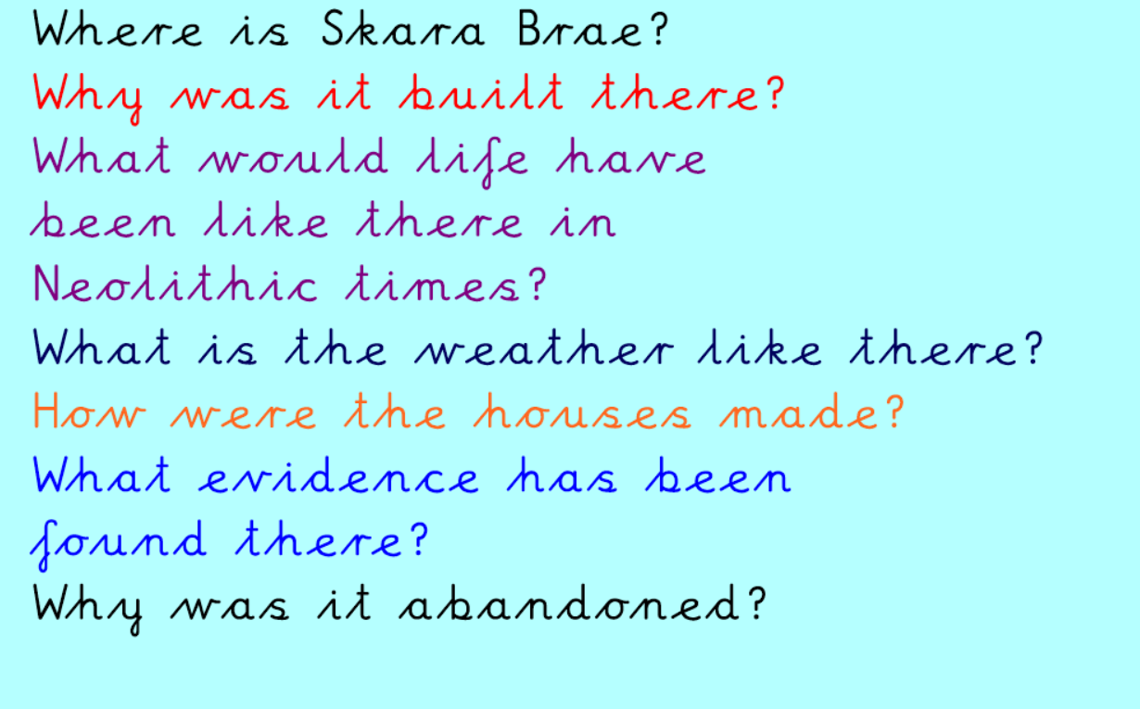
Use websites to find out about Skara Brae and make a tourist information leaflet.
https://www.natgeokids.com/uk/discover/history/general-history/skara-brae/
https://kids.kiddle.co/Skara_Brae
https://www.ks2history.com/skara-brae

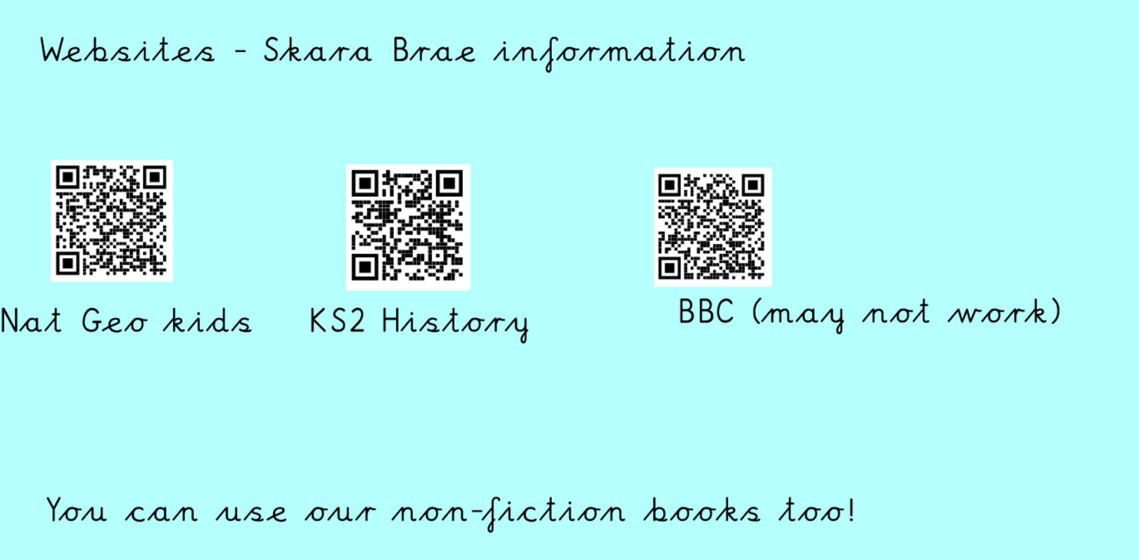
Example booklet
