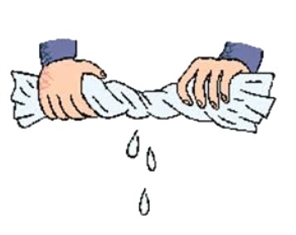

We do together

I do model

What do these quotes tell us about the character in the story? Explain as much as you can using evidence from the text.

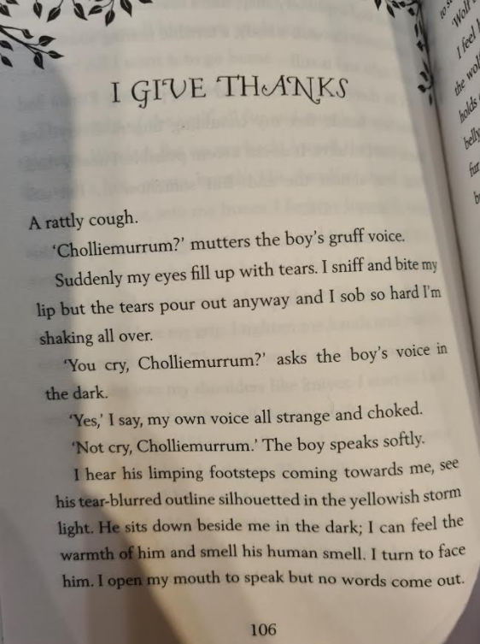

**A rattly cough**.

This tell us that the character could be poorly. Rattly implies that he has a chesty cough. Because there has been a storm and it has been raining, the character could have a cold.

It makes the reader feel sorry for this character already.

**I hear his limping footsteps coming towards me, see his tear-burred outline silhouetted in the yellowish storm light.**

**The boy is limping, so he is injured, yet he was still trying to help Charlie. He put Charlie before himself.**

**The boy is moving towards Charlie, but we know he is not a threat as he has saved Charlie from the wolf and has shown he cares for Charlie.**

**Wring it out**

**“You cry, Cholliemurrum,” asks the boy’s voice in the dark.**

**The boy is in the dark so he could be still keeping a distance from Charlie. When he says “you cry” he is showing that he cares for Charlie. He is starting to get close and build a friendship with him. It shows that his character is loving and makes the reader think that he is not a threat to Charlie.**

**“Not cry, Cholliemurrum.” The boy speaks softly**

**Again, this shows that the boy is being kind and caring towards Charlie. He cares and is trying to comfort him and support him.**

**By using the adverb “softly” the reader knows that the boy is not a threat to Charlie and begins to empathise with him.**