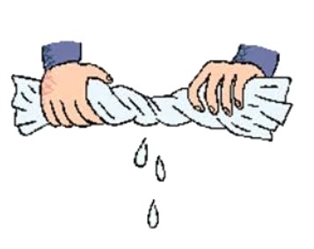

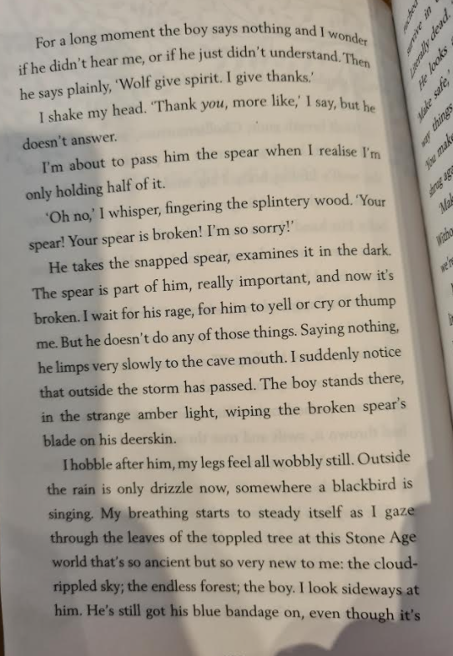

“Wolf give spirit, I give thanks.”

(The boy)

I hobble after him, my legs feel all wobbly still. My breathing starts to steady itself. (Charlie)

**Wring it out**

I wait for his rage, for him to yell or cry or thump me. But he doesn’t do any of those things. (The boy)

“Oh no,” I whisper, fingering the splintery wood. “Your spear! Your spear is broken! I’m so sorry!” (Charlie)