Dear Parents/ Carers,
Thank you so much for all of the support that you have given the children and us, this term. Despite us being in a challenging situation with Covid, you have all helped us to keep things as normal and safe as possible for the children. We have had an amazing term and have thoroughly enjoyed learning about The Stone Age and Skara Brae.
After Christmas, we will begin a new learning journey. This time, we will be heading for Pompeii and learning all about The Romans. As part of our Hook Day, on the first day back, we would like the children to dress up as a Roman. We appreciate that with Covid, sourcing costumes is difficult, so would suggest that the costume is kept as simple as possible. We have included some pictures below to give you some ideas of how you can make your own costume out of bed sheets or other similar material.
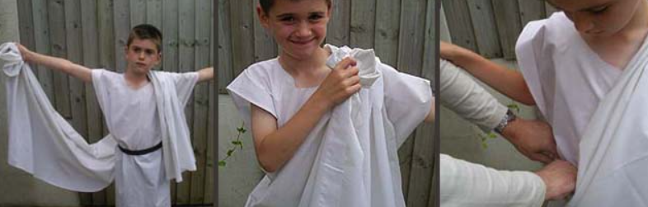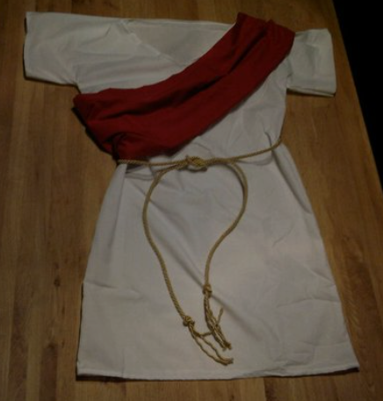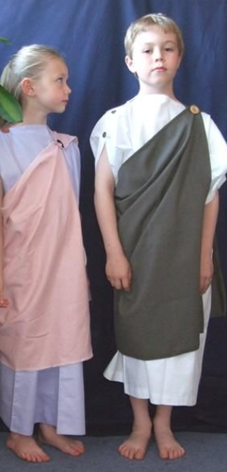

We will of course send you an overview of our learning journey in the New Year, so if you have any questions, please do not hesitate to get in touch.
The children have a homework menu of ideas to keep them occupied over the 2 week break, so please encourage them to share their amazing work with us all on dojo.
Have a super Christmas break and best wishes to you all for the New Year!
Your Sincerely,
Mrs langley, Mrs Wootton, Mrs Parker and Mrs Cooper

