Write a diary entry reflecting on Autumn Term. What did you learn? What were your experiences? How did you feel?

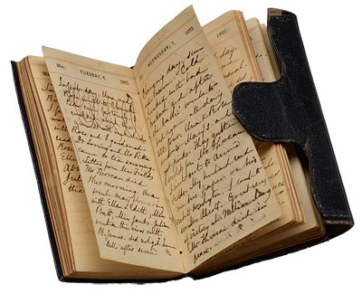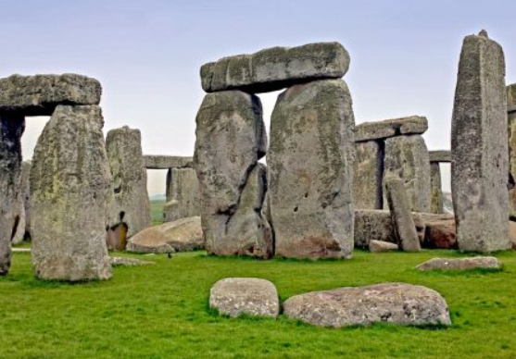

Find out what a volcano is and make a model volcano.

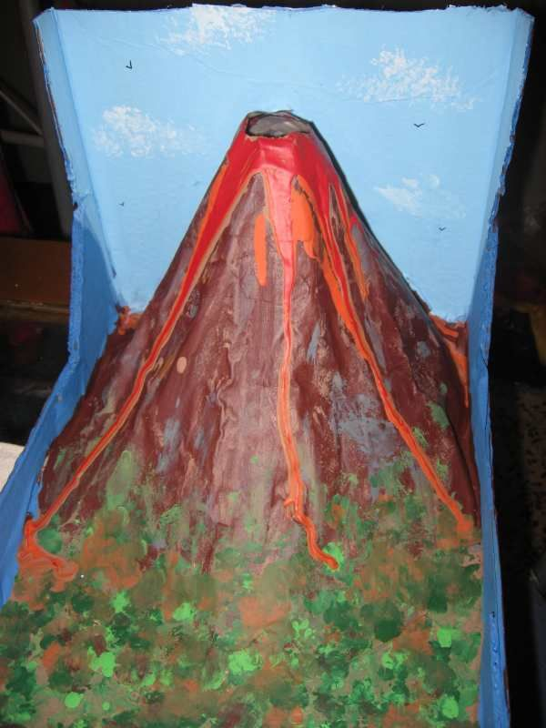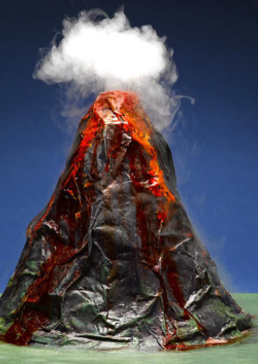

Complete as many tasks as you can – take a picture and upload it to dojo!

Make a Roman helmet or shield.

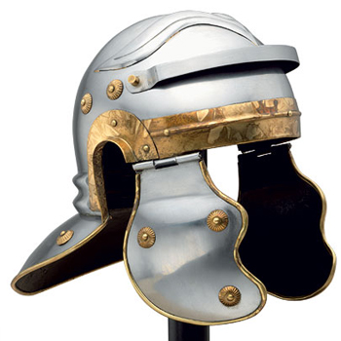 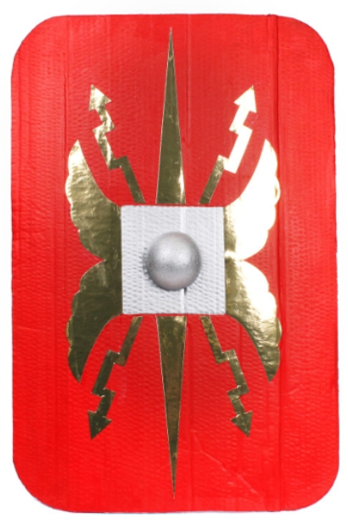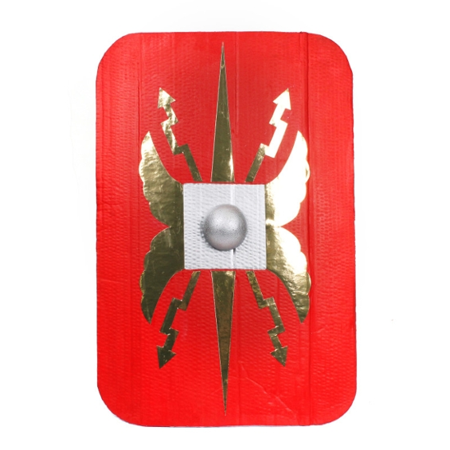

Who were the Romans? Find out about them

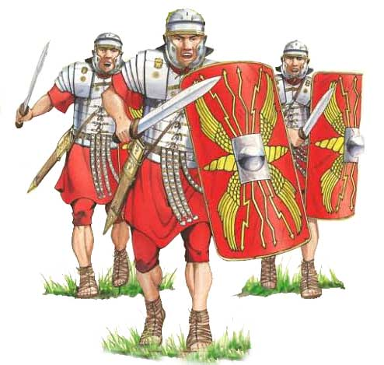

Find out about Roman Numerals – What are the numbers 1- 20 in Roman Numerals. 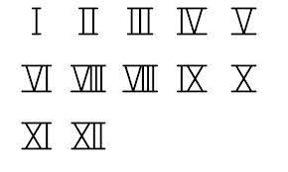

Read a book and make a video review of it. What did you enjoy about it and why?



Complete 10 games of TTRockstars in studio and earn your rock status certificate.



Make a tourist information leaflet about Hadrian’s wall.

