Look at the word cloud - do you still agree with your prediction? Why/ why not?
What are your predictions now?
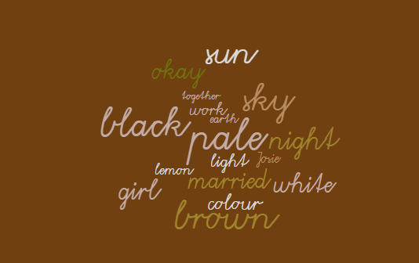
Look at the word cloud - do you still agree with your prediction? Why/ why not?
What are your predictions now?

