1.02.21
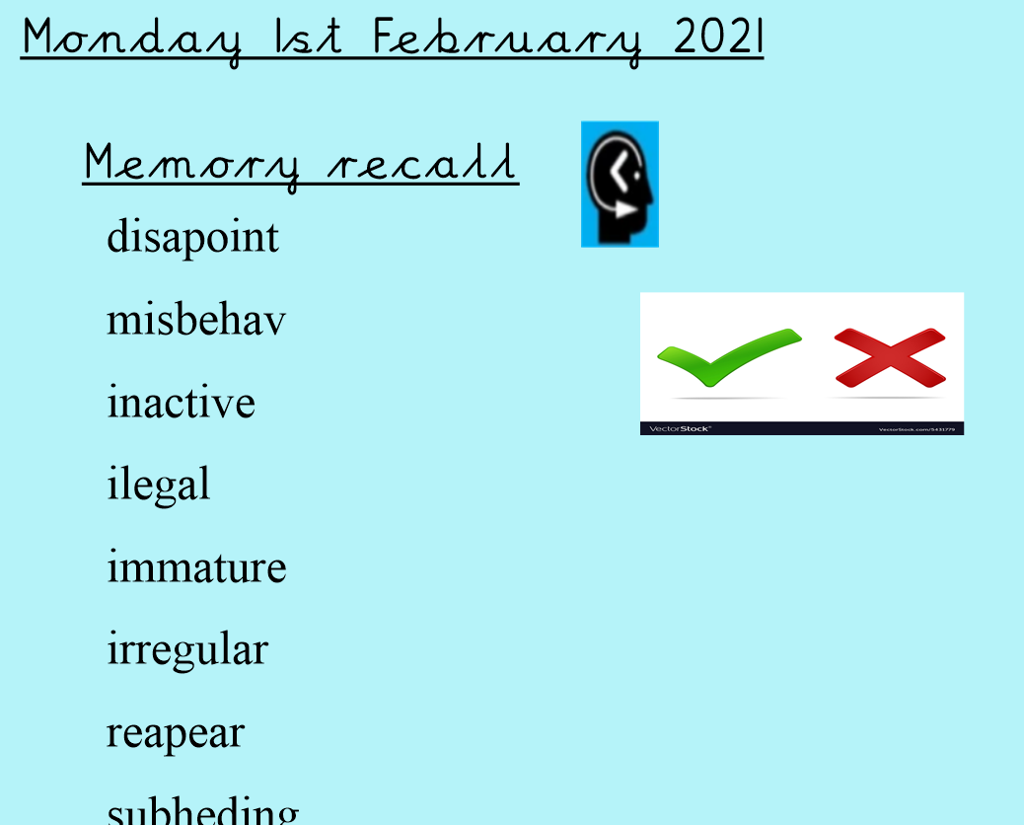

These are the spellings for this week, what do you notice?

Look, cover | Write and check | Write and check

