LI: To make predictions about a text using given details and my own inferences.
I will be successful if…
I can structure a written prediction with conjunctions to explain why.
I can structure a written prediction with modal verbs to show degrees of possibility.
I can generate questions from a given image.

On YouTube, find the following video:
https://www.youtube.com/watch?v=pQmk8dUFHHY
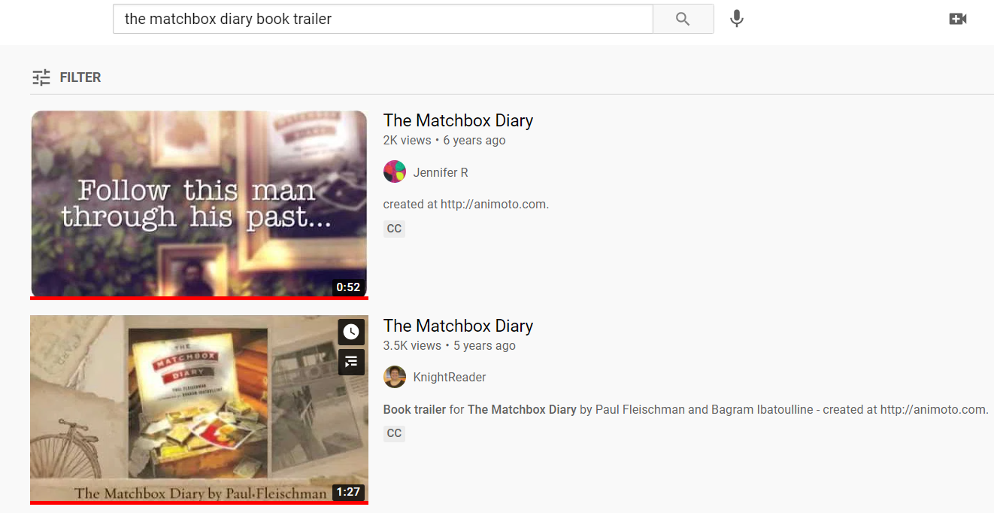

PRESS PLAY BUT DO NOT WATCH! LISTEN TO THE MUSIC ONLY.
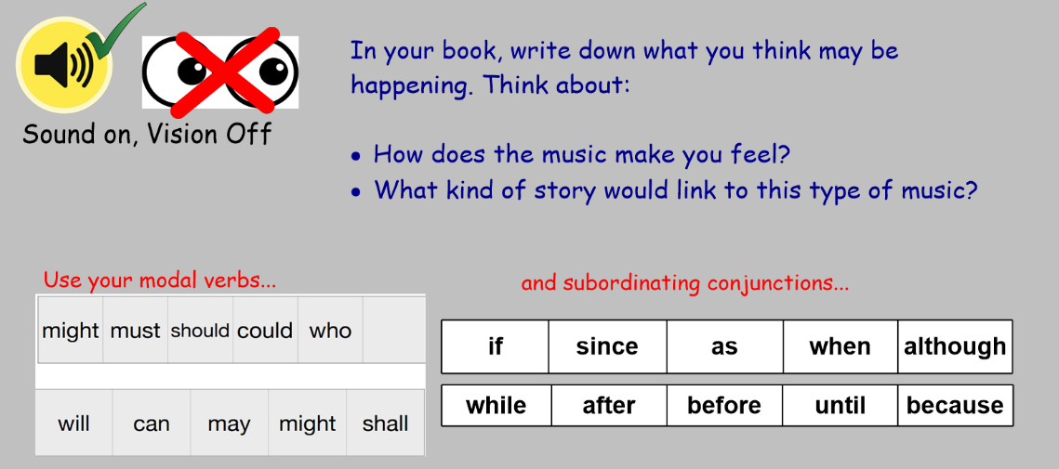

Write your ideas below.

