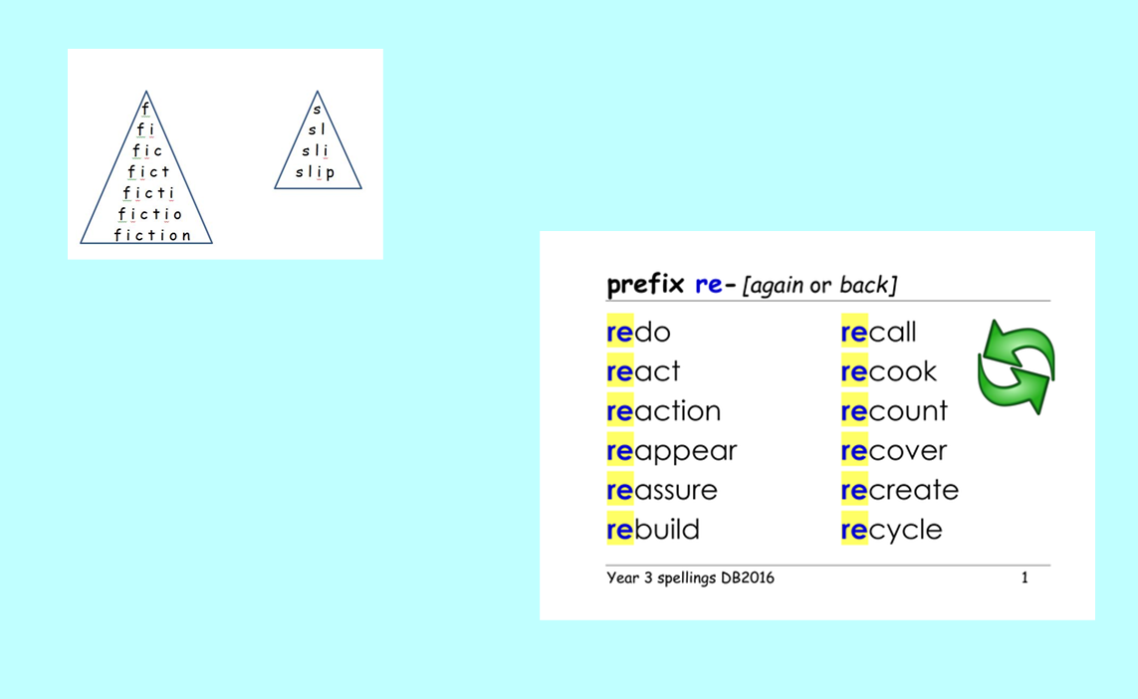
What do you notice about all these words? What does this prefix do to the meaning of these words?

Can you use pyramid writing to help you learn to spell these words.

