LI: To generate description from a given image.
I will be successful if…
I can generate adjectives to help describe a setting.
I can create expanded noun phrases to build my description.
I can collate ideas together to create a descriptive paragraph.

Adjectives are describing words e.g. fat, tall, red, horrible

Expanded noun phrases use two adjectives separated by a comma and a noun:
- fat, brown dog
- tall, skinny man
- huge, red ball
- horrible, stinky fish

Turn these noun phrases into expanded noun phrases:

big tower =

terrifying teacher =

delicious biscuit =

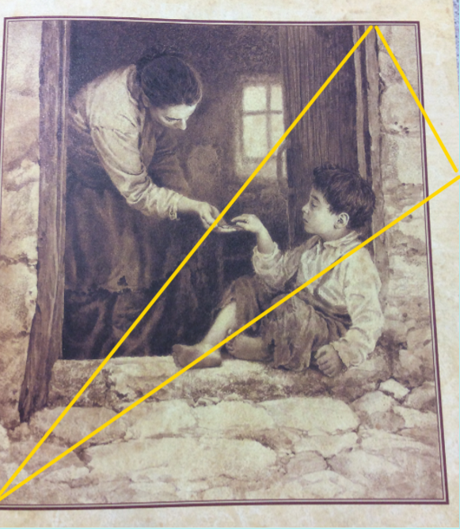

Torchlight
Starting from the actual point, work your way up the inside of the torchlight towards the top right corner. What do you see first?
What comes next? Then?

What expanded noun phrases can you create?

Collate your ideas and then write a descriptive paragraph for this scene.

