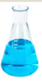
LI: To investigate if seeds germinate in different water solutions.
I will be successful if…
I can recognise when and how to set up comparative and fair tests
I can explain which variables need to be controlled and why
I can observe seed growth over time and record my results.
I can make conclusions at the end of my investigation.

Our new unit is Living Things and Their Habitats. What do you already know about these things?

Life Cycle - A life cycle shows how things are born, how they grow and how they reproduce.
What things can you now think of, that are living, which go through a life cycle?

Animals and plants are living things which go through a life cycle. We will start by looking at plants.

The first process a seed needs to go through in order to grow is germination.
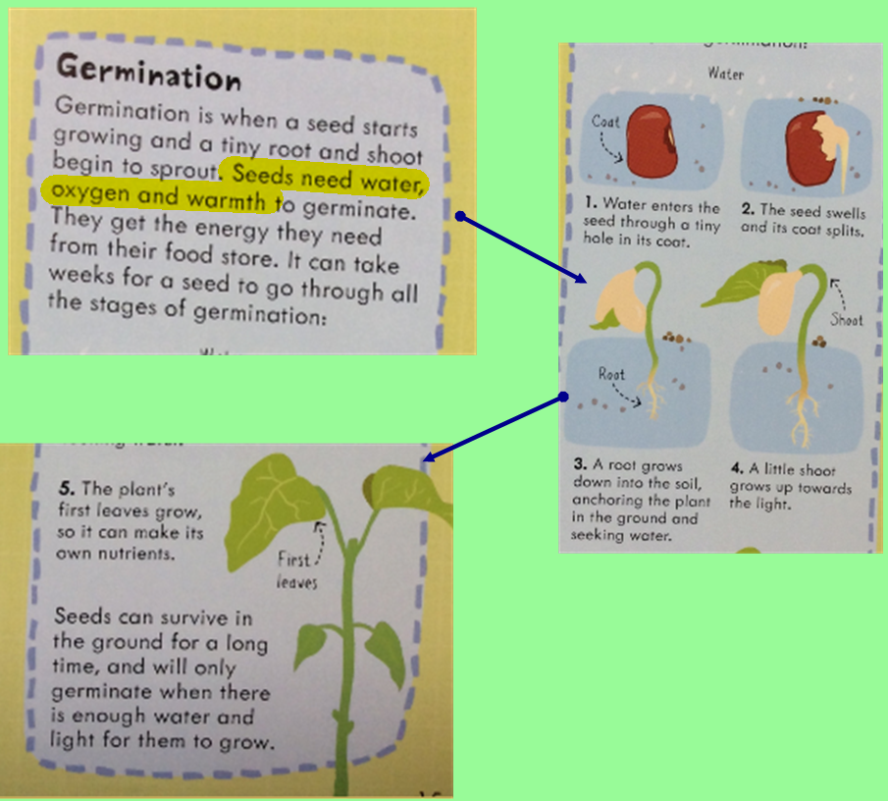

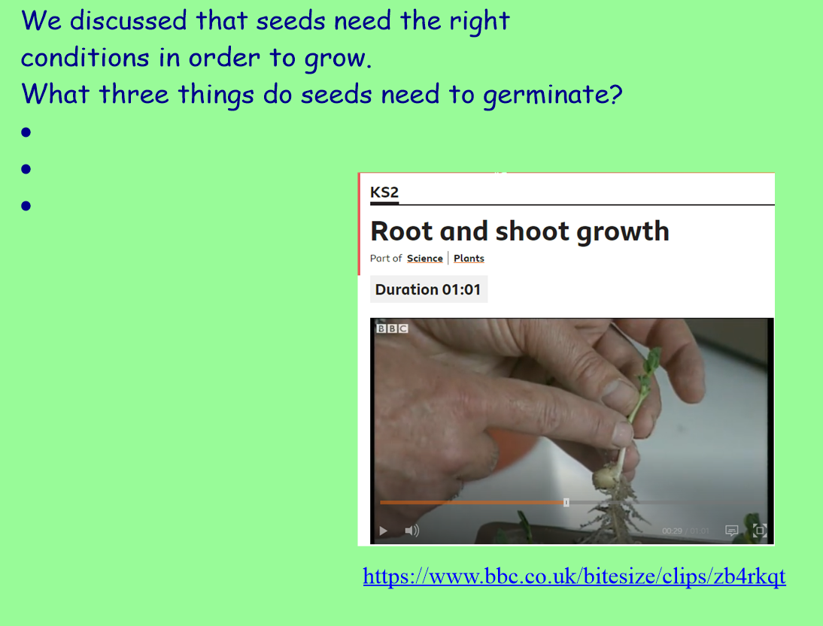

Does the type of water affect how well a seed will grow? Will seeds germinate in salty or oily water?
What do you predict?

