LI: To understand how a character may be feeling at key points of the story.
I will be successful if…
I can suggest what a character’s emotions might be.
I can weigh up a characters decision using a decision wheel.
I can state what I would do in the same situation and explain why.
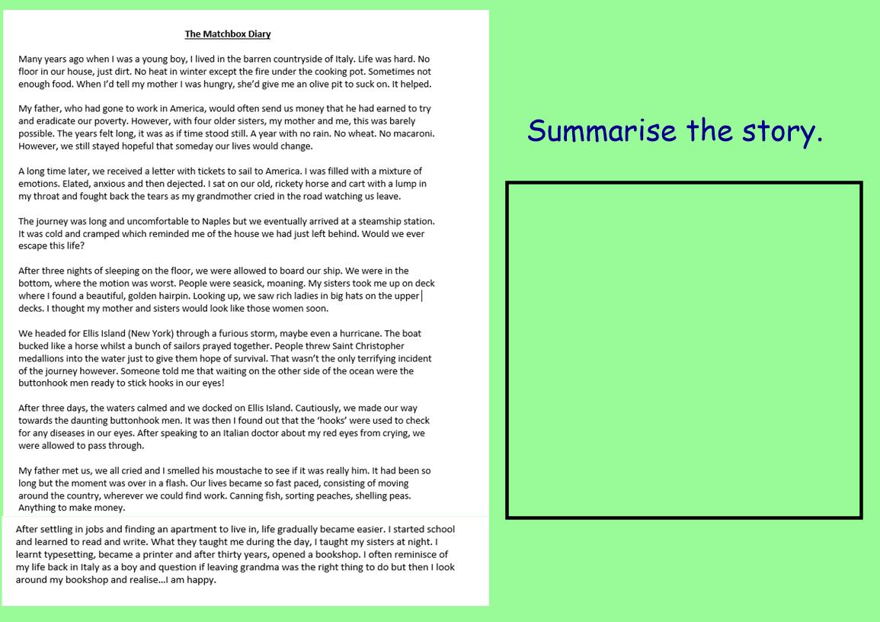

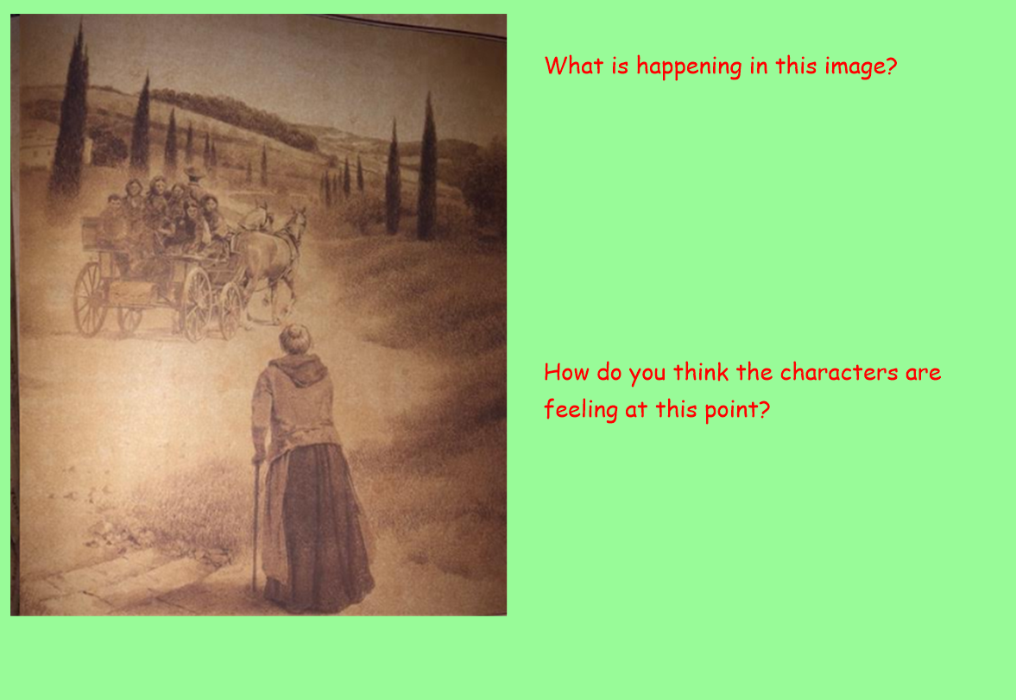

Decision Wheel – Content Domain 2b, 2d
Should the family leave home or not?

