LI: To discuss and compare the life of the main character in The Matchbox Diary.
I will be successful if...
I can recognise key events of the story that would impact the main character’s life.
I can use a comparison grid to record my ideas.
I can use comparative language to explain similarities and differences.

Life before the move to America | 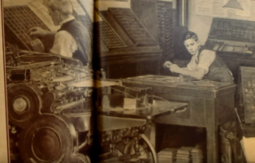  Life after the move to America
Comparison Grid

Challenge: Write a diary entry as the man telling the audience about how his life had changed.

