LI: To convert mixed numbers to improper fractions.
I will be successful if…
I can recognise improper fractions pictorially.
I can convert an improper fraction to a mixed number.
I can convert a mixed number to an improper fraction.
I can solve problems involving improper fractions and mixed numbers.
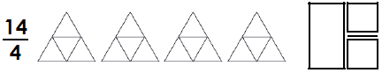
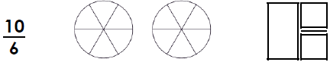
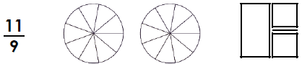

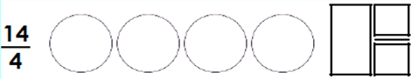
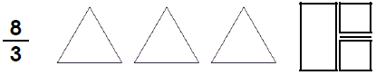

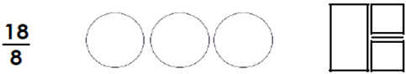

Challenge
