Tuesday 26th January 2021
Content Domain: 1a draw on knowledge of vocabulary to understand texts
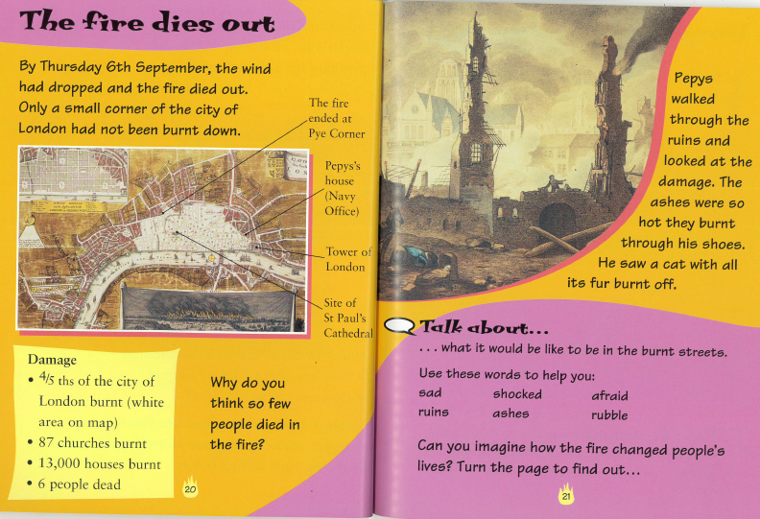
Read the text with an adult, remember to point to the words to help you follow the text.

What would it be like to walk through the burning streets of London City? Try to use some of the new vocabulary (words) you have learned in the text.

_________________________________________________________________________________________________________________________________________________________________________________________________________________________________________________________________________________________

