LI: To write the introduction to my story using main and subordinate clauses.
I will be successful if…
I can use an appropriate subordinating conjunction in my sentence.
I can identify main and subordinate clauses in my writing.
I can move clauses around to create a variety of sentences.

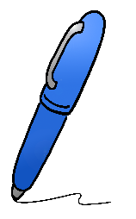
What do the following sentences all have in common? (Makes them the same?)
Shared Writing
When it rains, we don’t go to the park.
Although it’s raining, we’ll still go to the park.
Because it’s raining, we won’t go to the park.
Since it is raining, we won’t go to the park.
As it rained, we didn’t go to the park.
Until it has stopped raining, we won’t go to the park.
If it rains, we don’t go to the park.

Challenge
Move the clauses around so the conjunctions are in the middle of the sentence.

Write the introduction to your story using main and subordinate clauses. Try and use a variety of sentence starters as well.

