LI: To create show not tell sentences to convey the emotions of a character.
I will be successful if…
I can explain physical characteristics that link to emotions
I can ‘show’ an emotion by not saying what the emotion is
I can use show not tell to up level my work.
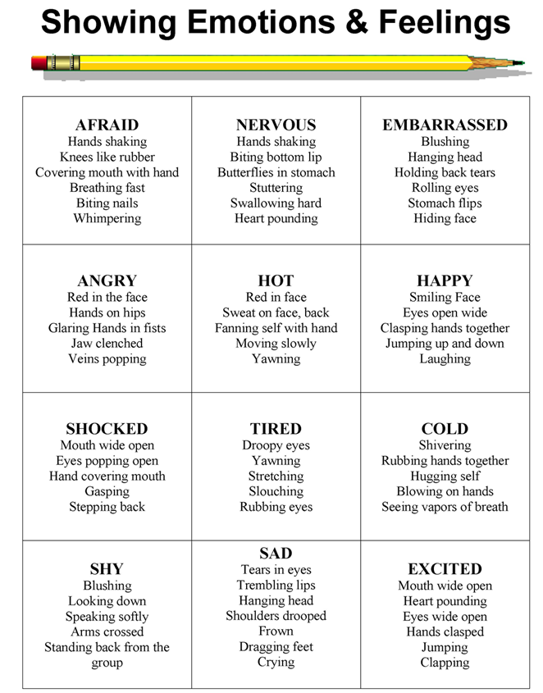

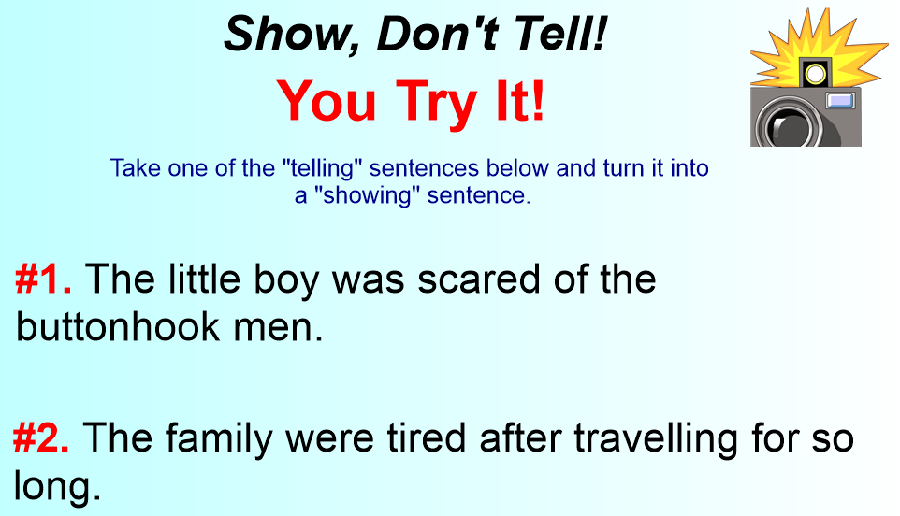

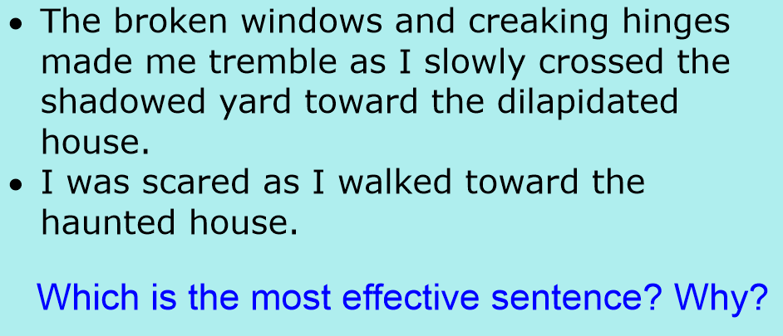

Shared Writing

Continue writing your story. Try and use show not tell sentences (not in every sentence) and continue to develop your understanding of main and subordinate clauses.

- Quick write
- Add
- Replace
- Take Away
- Read Aloud

