Wellbeing Wednesday Menu

How many of the following activities can you complete today? Make sure you upload your pictures/videos to Dojo!
Go on a nature walk | Do some yoga  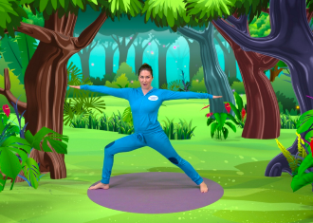 | Play a board game  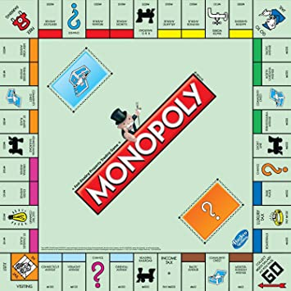
Bake a cake | Read a book | Complete a Joe Wicks Workout  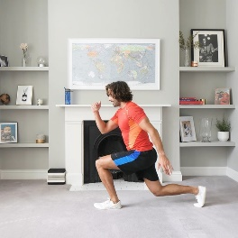
Complete some North Yorkshire Sport Challenges | Build something out of Lego  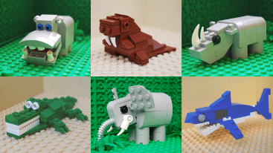 | Do something you enjoy doing!

YouTube - Cosmic Kids Yoga
- Joe Wicks Workouts (15 minutes)
- North Yorkshire Sport - https://www.northyorkshiresport.co.uk/simple-at-home-activities

