28.1.2021
Maths- Home learning
LI: To be able to find a third, a half and a quarter of an amount
I am able to understand how to use a bar model when finding a fraction of an amount.
I am able to use practical resources to find a third of an amount.

Today we are consolidating how to find a fraction of an amount.. Use the bar model to help you share out the numbers equally.
If you’re finding out a half you will have to split the bar into 2.
If you’re finding out a quarter you will have to split the bar into 40
Eg.

12
6 | 6

12
3 | 3 | 3 | 3
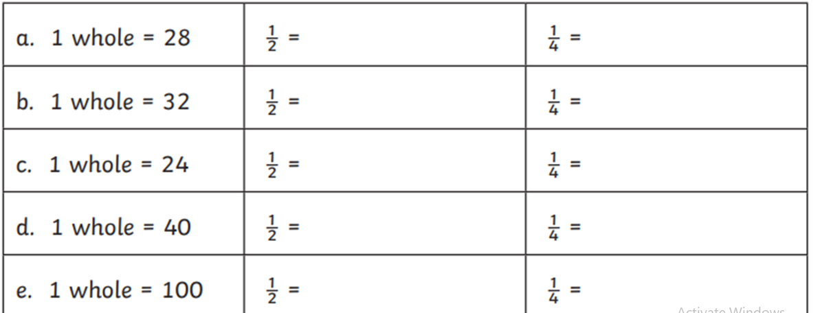

Challenge:
