Tuesday 26th January
LI: To know by heart the multiplication and division facts for the 4 times tables.
Complete the times tables below and write the rest of the fact families for each one.
e.g. 8 x 4 = 32 4 x 8 = 32 32 ÷ 4 = 8 32 ÷ 8 = 4
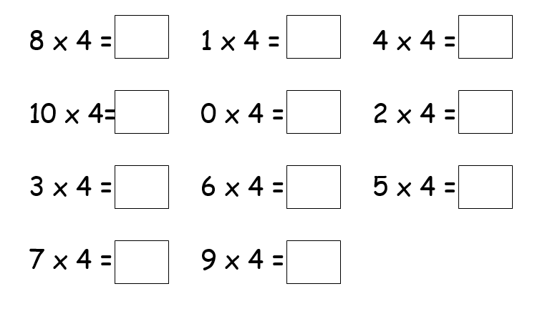
Now complete these questions, applying your tables knowledge to some fluency questions.
