Thursday 28th January 2021
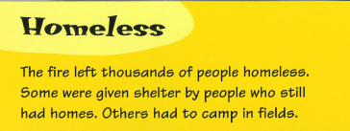
Content Domain: 1b explain key aspects of non-fiction texts.

Compare the picture you drew yesterday with the one from the book.
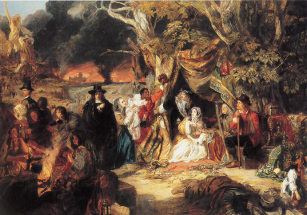
What is the same about your picture and the one in the book?
_____________________________________________________________________________________________________

What is different about your picture and the one in the book?
______________________________________________________________________________________________________

