Multiplying by 10
Read the following explanation of how to multiply by 10 or 100. Then have a go at the activity.
Upload a picture of your work to your dojo portfolio or to google classroom.
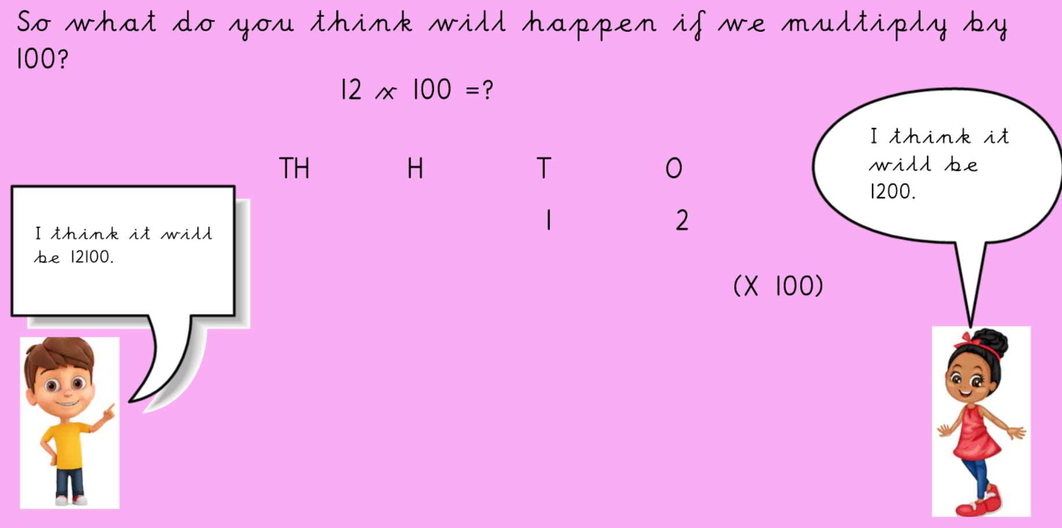

Now have a go at the activity provided and upload the pictures to dojo or classroom.

