Acting
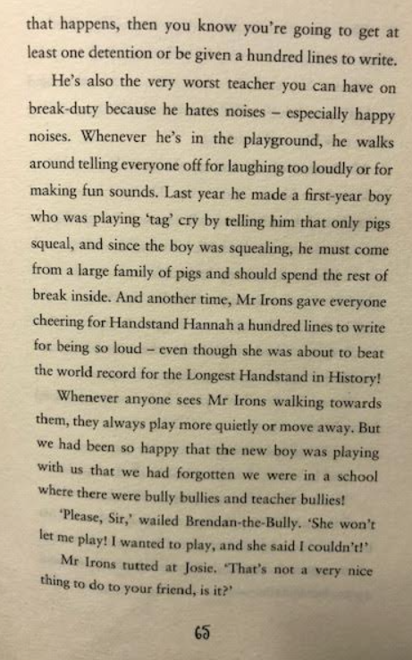
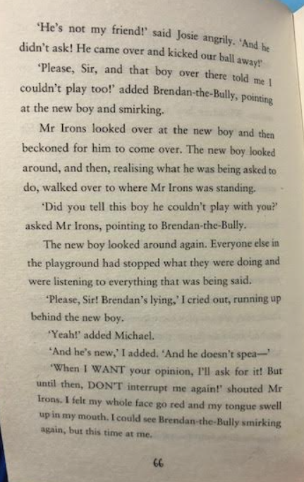
Act out the conversation between Mr Irons and the children on pages 65 – 66, film yourself and upload it to dojo. You may need help from siblings!

- Think carefully about your expression
- Think about your body language and facial expressions.

