LI: To change mixed fraction to proper fractions.
I know what the denominator and the numerator are
I know that a mixed fraction is when the numerator is bigger that the denominator.
I know to change to a proper fraction I need to divide.
I remember that what is remaining is the fraction left over.
You do…
Change these mixed fractions to proper fractions.
- 7/3
- 5/4
- 9/2
- 15/4
- 23/8
- 30/9

Challenge…

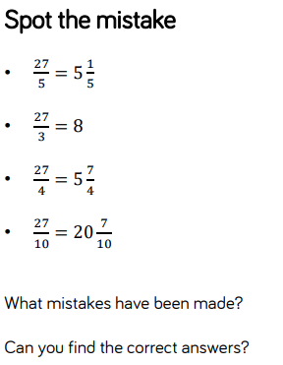

Challenge…

