LI: To convert mixed numbers to improper fractions.
I will be successful if…
I can multiply the whole number by the denominator.
I can add the numerator onto the answer to create my total
I know to keep the denominator the same.
I can check I have the correct answer by converting it back to a mixed number.
You do:
Covert these mixed fractions to improper fractions
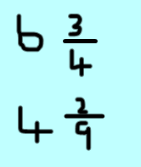

Challenge:
Challenge:
