LI: To add and subtract fractions with the same denominators
I will be successful if…
I know that when I add and subtract the denominator stays the same.
I know to add and subtract the numerator.
I can simplify my fraction.
I can answer a range of questions relating to adding and subtracting fractions with the same denominator.
You do:
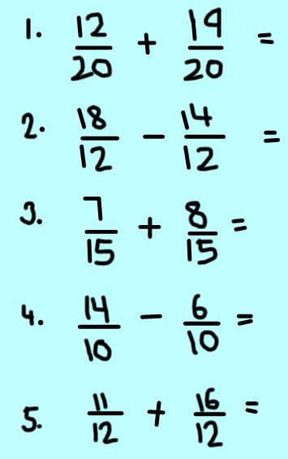

Can you simplify the fractions further?
Can you convert them into mixed numbers?

Challenge 1:

Challenge 3:
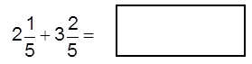

Challenge 2: Correct Mr Wallis mistake

2.

