Art – 1.02.21

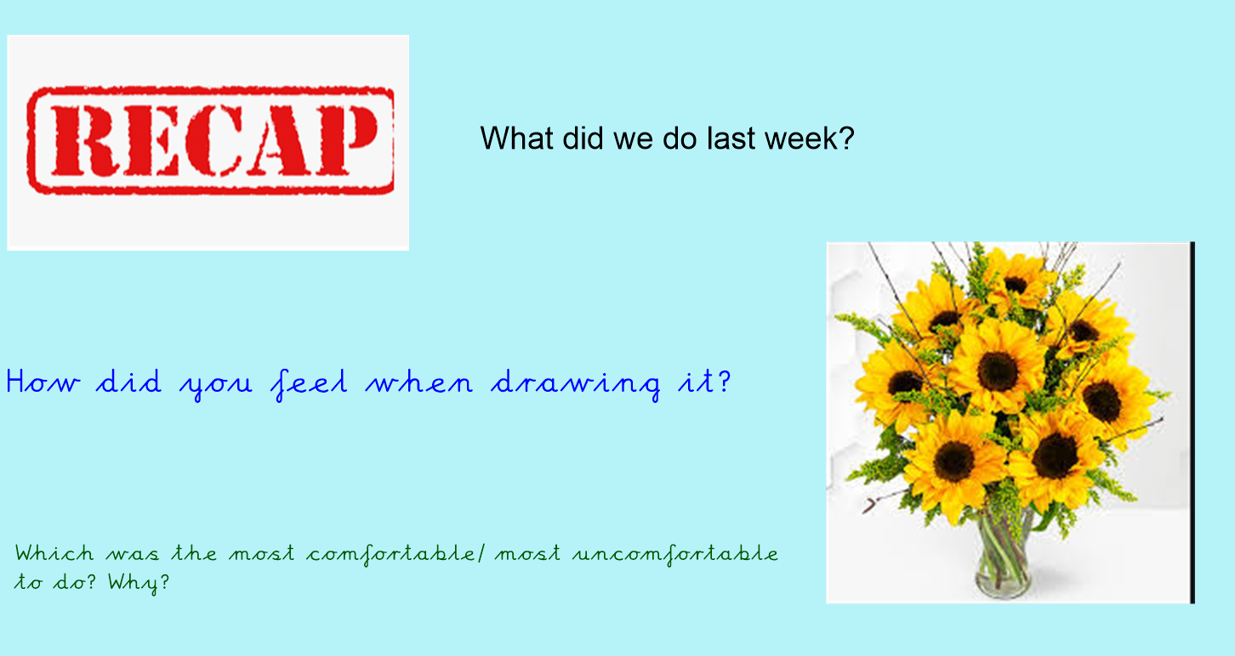

Read about this famous Artist, we are going to produce some art using her techniques.

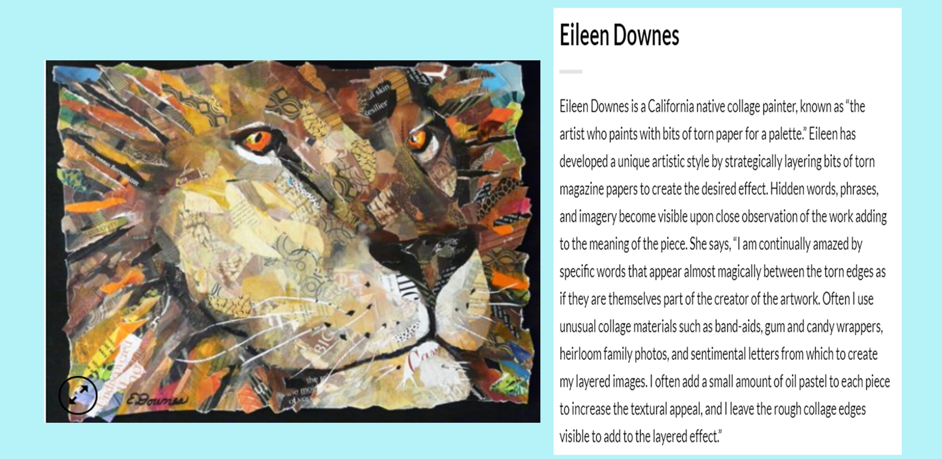

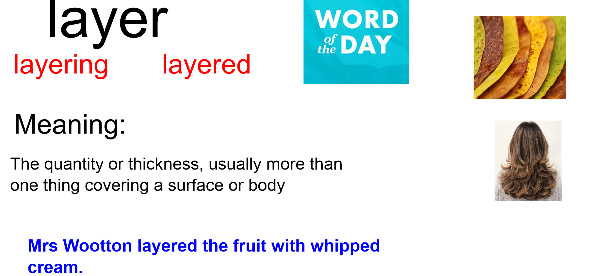

Here is some of her work:
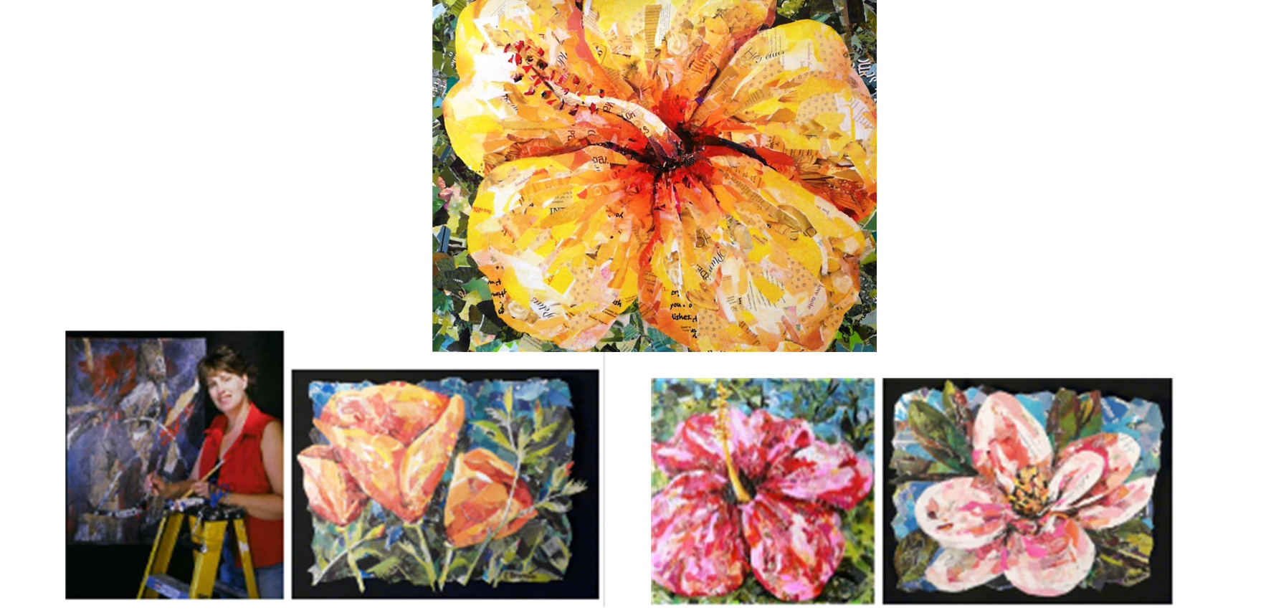

We are going to think about how Artists use colour to reflect MOOD
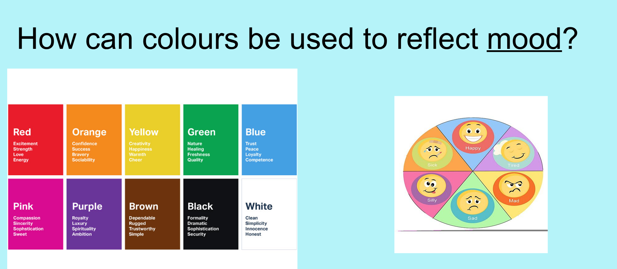

ANNOTATE THE PICTURE OF THE FLOWER SHOWING REASONS THE COLOURS ARE USED:
