Challenges – Multiplication and division

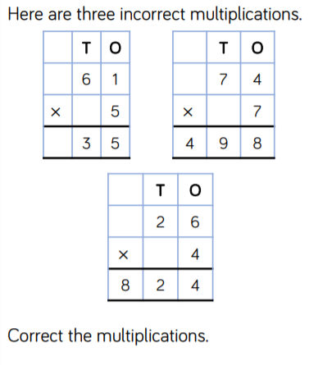
Once you have corrected them, do the inverse short division calculation to prove you are correct.

