DIY Pop-Up: Frankenstein
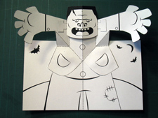
PDF Templates
For this DIY Pop-Up you will need:
- Cardstock or heavy construction paper
- Scissors
- Ruler
- Paper clip, or ballpoint pen that has run out of ink, or a knitting needle
- Crayons, colored pencils, markers

Instructions
1 Download the PDF templates and print out at 100% size (no scaling) on a heavy paper, such as cardstock.
2 Color all of your pieces with crayons or markers before scoring and cutting.
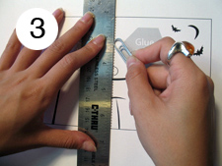
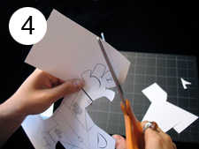
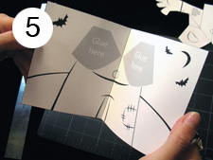
3 Using a ruler as a guide, take the rounded end of a paper clip (or ballpoint pen that has run out of ink) and press along the dotted lines of the pop-up pieces and card.
4 Carefully cut out the pop-up pieces and card following the solid, black lines around the OUTSIDE of the shapes ONLY.
5 Take your card, fold it in half and then open it. Set it aside.
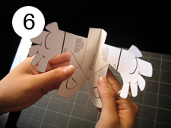
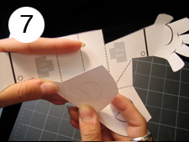
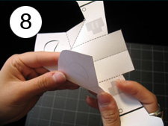
6 Take the body piece and fold it in half and then open it.
7 Fold the bottom left edge of the coat up to the right arm and return it.
8 Now fold the bottom right edge of the coat up to the left arm and return it.
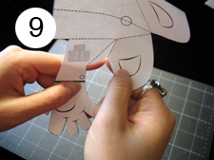
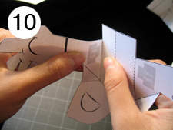
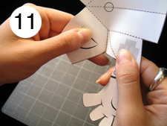
9 Hold the left arm in one hand and the left pocket in the other and bend towards you at the dotted line.
10 Hold the left shoulder in one hand and the chest in the other and bend towards you at the dotted line.
11 Hold the right arm in one hand and the right pocket in the other and bend towards you at the dotted line.
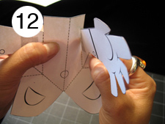
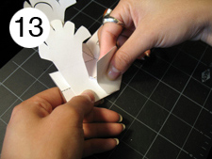
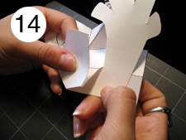
12 Hold the right shoulder in one hand and the chest in the other and bend towards you at the dotted line.
13 Press the left shoulder to the chest and hold while you fold the left edge of the coat up to the right arm and then return them to the original position.
14 Press the right shoulder to the chest and hold while you fold the right edge of the coat up to the left arm and then return them to the original position.
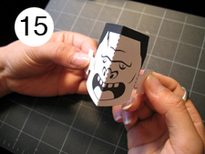
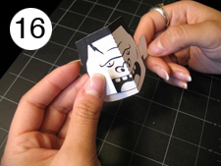
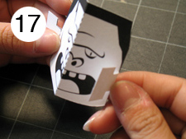
15 Set the body piece aside. Pick up the monster’s head and fold it in half and then open it.
16 Fold the left bolt towards the face along the dotted line.
17 Fold the right bolt towards the face along the dotted line.
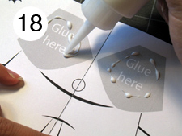
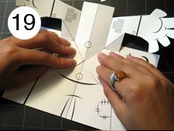
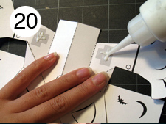
18 Pick up the card with the legs on it. Place a small amount of glue on the grey areas marked “glue here.”
19 Align the pockets of the body piece over the matching grey areas. Make sure that the line down the middle matches the line in the card. Press firmly and be sure let the glue dry.
20 Place a small amount of glue on the grey areas marked “glue here” on the shoulders.
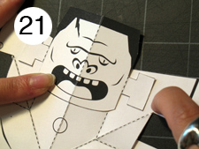
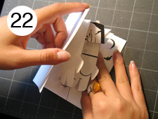
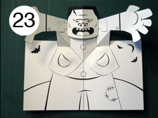
21 Align the bolts of the head over the matching grey areas. Make sure that the line down the middle of the head matches the line in the body. Press firmly and be sure let the glue dry.
22 Now carefully close your card and press firmly.
23 Open the card and watch Frankenstein’s monster rise up and give you a big Halloween hug!

http://www.matthewreinhart.com/2012/10/23/diy-pop-up-frankenstein/

