Content Domains: 2b, 2d, 2g
Question Time
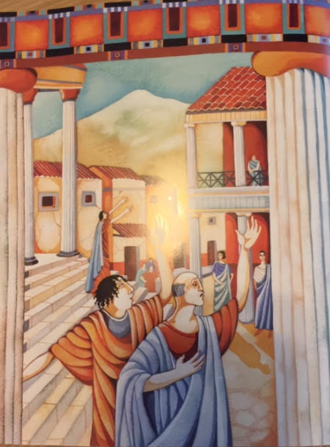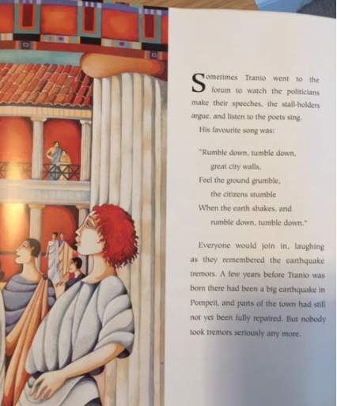
Find and copy three things which Tranio did at the forum.
____________________________________
____________________________________
____________________________________

Find and copy one word which shows the people of Pompeii were not worried about the tremors.
____________________________________

How do we know that Pompeii is unsafe? Find and copy a phrase.
_____________________________________________________________________________________

Why weren’t the people of Pompeii concerned about the tremors or volcano? Explain your answer fully.
__________________________________________________________________________________________________________________________________________________________________________________________________________________________________________________________________________________________________________________________________________________________________________________________________________________________________________________________________________________________________________________________________________

