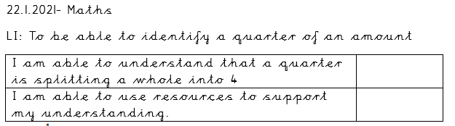
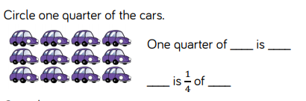
Circle one quarter of the apples:
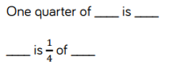
Circle one quarter of the apples:
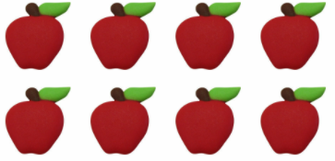
Circle one quarter of the apples:
