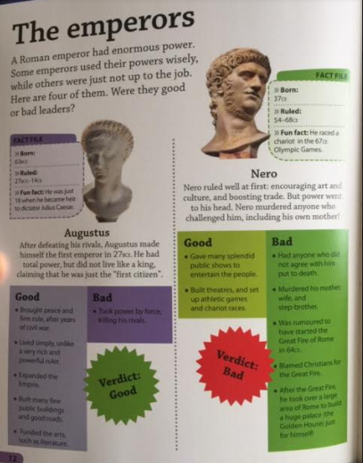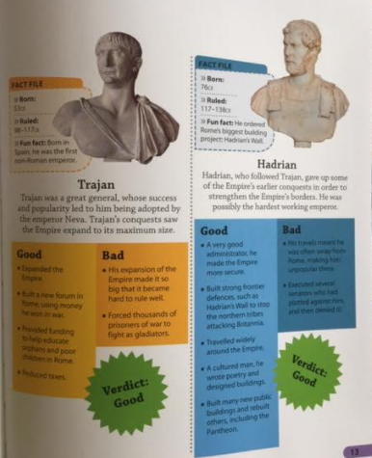

**Friday 29th January**

**The emperors**

**Create a fact file for each emperor**

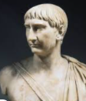

**Trajan**

**Born:________________**

**Ruled: _______________**

**Good:_________________________________________________________________________________________________________________________**

**Bad:________________________________________________________________________________**

**Fun Fact:_____________**

**__________________________________________**

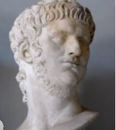

**Nero**

**Born:________________**

**Ruled: _______________**

**Good:_______________________________________________________________________________**

**Bad:__________________________________________________________________________________________________________________________**

**Fun Fact:_____________**

**__________________________________________**

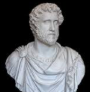

**Hadrian**

**Born:________________**

**Ruled: _______________**

**Good:_________________________________________________________________________________________________________________________**

**Bad:________________________________________________________________________________**

**Fun Fact:_____________**

**__________________________________________**

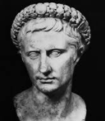

**Augustus**

**Born:________________**

**Ruled: _______________**

**Good:_________________________________________________________________________________________________________________________**

**Bad:___________________________________________________________**

**Fun Fact:_____________**

**__________________________________________**