Friday 5th February
LI: to be able to use inverted comma to show dialogue
I will be successful if:
- I can explain what inverted commas are what they are used for
- I can identify where they go in a sentence
- I can write dialogue using inverted commas
Look carefully at the sentence below. Which parts are being spoken? Put inverted commas at the beginning and end of those spoken words.
Look! Vesuvius is exploding we must leave now! screamed Lucas. Quick get onto the boat. We have to escape.
Give me your hand, I’ll help you into the boat. Lucas shouted to the people on the harbour.
Lucas rowed with all his strength, We need to get as far away as we can. he said to his passengers.
The water grew rough, Watch out for the waves! Lucas warned.

Sentence Creator- write dialogue for each picture using inverted commas to show what is being spoken
Tranio and Livia seeing Vesuvius erupt.
Tranio and Livia running through the streets as Vesuvius erupts.
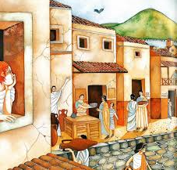
When the earthquake happens.
Tranio looking out at Pompeii in the morning.
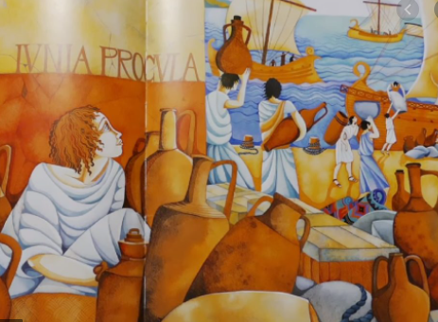
Tranio watching the ships at the harbour.
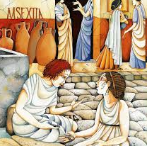
Tranio and Livia playing games in the street.

