Friday 22nd January
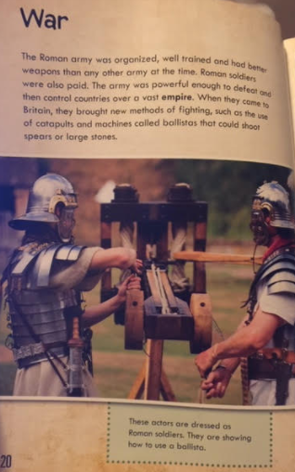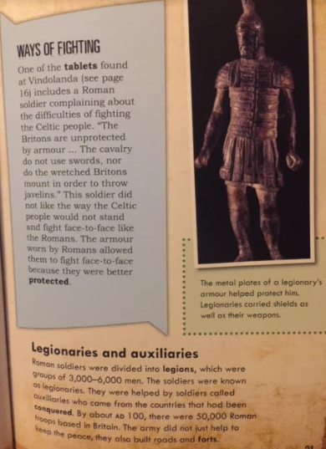
Read the text above and answer the questions
- Why was the Roman army better than any other army? Tick two
They had better weapons
They were stronger
They were fierce
They were well trained

- What was the Roman army able to do? Find and copy a phrase.
________________________________________________
- Find and copy two new weapons which the Romans brought to Britain.
________________________________________________
________________________________________________
- Page 21. Why didn’t the Roman solider like the Celtic people. Tick three.
They are unorganised
They don’t use armour
They run away
They didn’t throw weapons from horses
They don’t have good weapons
They don’t stand face to face to fight

- Which one word tells the reader that the armour keeps the soldiers safe?
________________________________________________
- Page 21. Find and copy three things which the army does?
________________________________________________
________________________________________________
________________________________________________
- How many soldiers were in Britain by 100 AD?
________________________________________________

