Friday 22nd January / Li: to be able to write the build up of a Rags to Riches story (trickiest)
I will be successful if:
- I can use coordinating conjunctions (and, so, but)
- I can use subordinating conjunctions (because, while, when)
- I can use expanded noun phrases (2 adjectives before the noun)
- I can use verb
- I can use adverbs
- I can use prepositions for time (before, soon, after) and place (beside, above, below)
- I can use adverbs for time (suddenly, immediately, unexpectedly)
- I can use fronted adverbials (all of a sudden, without warning, in the distance)
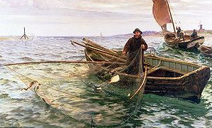
Action Points to include:
- Describe and explain Lucas’ hard life: he worked all day, got no pay, little food, slept on the fishing nets.
- Describe what Lucas does for his job and where he does it.
_________________________________________________________________________________________________________________________________________________________________________________________________________________________________________________________________________________________________________________________________________________________________________________________________________________________________________________________________________________________________________________________________________________________________________________________________________________________________________________________________________________________________________________________________________________________________________________________________________________________________________________________________________________________________________________________________________________________________________________________________________________________________________________________________________________________________________________________________________________

