Friday 29th January
LI: to be able to write expanded noun phrases to describe an image
I will be successful if:
- I can identify nouns
- I can use adjectives to describe the nouns
- I can combine these to form an expanded noun phrase
- I can include additional details after the noun
Part 1: Create a list of nouns and adjectives for each image.
Nouns | Adjectives
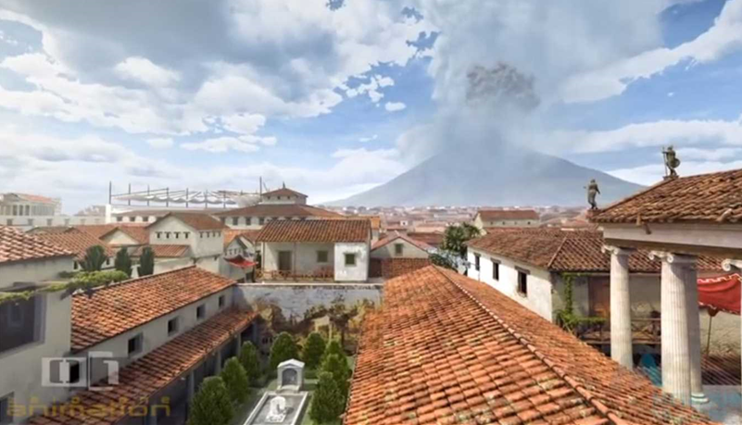

Nouns | Adjectives
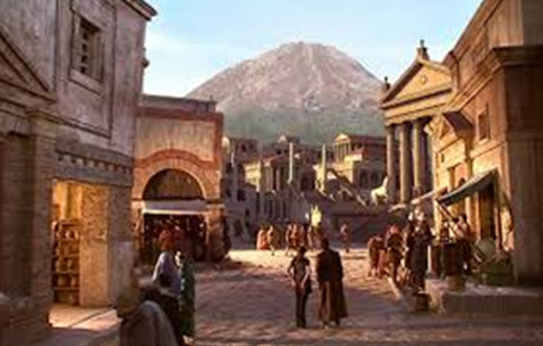

Nouns | Adjectives
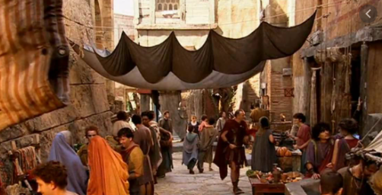

Part 2: Write expanded noun phrases sentences describing the pictures (2 adjectives to describe the noun e.g. The busy, crowded street. Tall, ancient buildings. )
________________________________________________________________________________________________________________________________________________________________________________________________________________________________________________________________________________________________________________________________________________________________________________________________________________________________________________________________________________________________________________________________________________________________________________________________________________________________________________________________________________________________________________________________________________________________________________________________________________________________________________________________________________________________________________________________________________________________________________________________________________________________________________________________________________________________________________________________________________________________________________________________________________________________________________________________________________________________________________________________________________________________________________________________________________________________________________________________________
__________________________________________________________________________________________________________________________________________________________________________________________________________________________________________________________________________________________________________________________________________________________________
_________________________________________________________________________________________________________________________________________________________________________________

