L.I:- To be able to apply problem solving startegies.
I will be sucessful if..
- I can read and annotate the question.
- I can recall which strategy to use.
- I can apply the 4 operations knowledge.

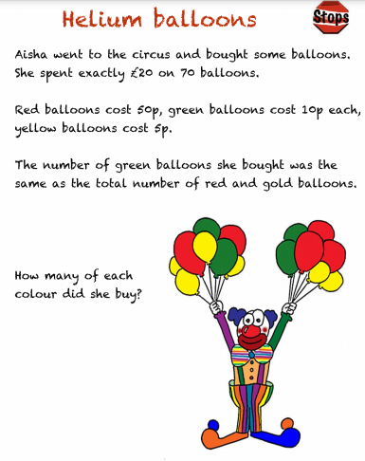

L.I:- To be able to apply problem solving startegies.
I will be sucessful if..
- I can read and annotate the question.
- I can recall which strategy to use.
- I can apply the 4 operations knowledge.

