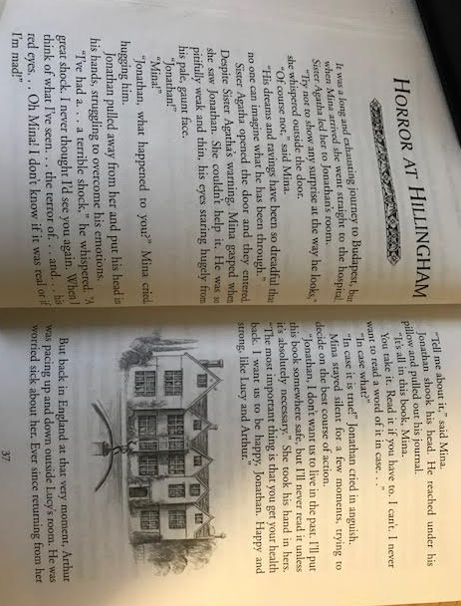
Friday
Skill Check: Retrieve and Record Information (2b)

Match the event to Mina’s emotion.
Travelling to Budapest
Seeing Jonathan for the first time-
Hearing Jonathan’s distressed ranting
Deciding not to read the journal
accepting
hesitant
shocked.
exhausted

Complete the table about Mina’s experience.
Where did she travel to?
Who did she first meet at the hospital?
How is Jonathan described when Mina first see him?

Friday
Question Time
Which phrase tells us the Lucy’s health has got worse?
___________________________________________________________________________
Find and copy 2 ways Jack is described after leaving Lucy.
___________________________________________________________________________
Why is working with Lucy difficult for Jack?
___________________________________________________________________________
How does the reader know that Arthur is furious at Jack’s diagnosis of Lucy? Find and copy one word.
___________________________________________________________________________
List 2 things which Lucy complains of.
___________________________________________________________________________
Who is Professor Van Helsing?
___________________________________________________________________________
Hints and Clues
Certain: What is wrong with Lucy? | Hints: What do you think is wrong with her? What will happen to her?

