L.I:- To be able to recognise and use first quadrant
I will be successful if…
- I can read and understand the axis.
- I can read and plot coordinates.
- I can draw 2d shapes.

Try it!
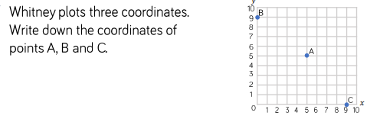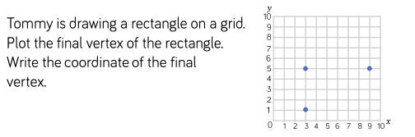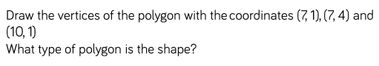

Apply it!
