Skill Check: retrieval and record (2b)
Retrieve and record questions ask for you to search in the text for the precise answer.
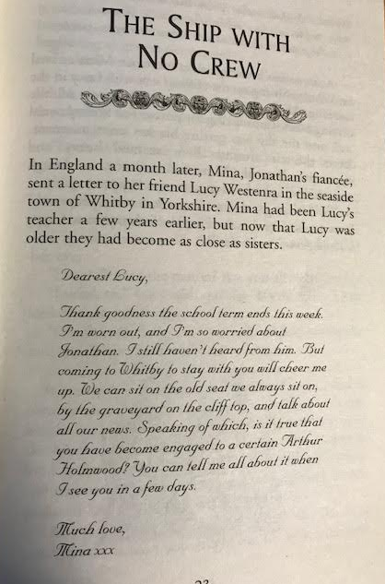
Who is Mina writing to?
___________________________________________________________________________
How are Lucy and Mina connected?
___________________________________________________________________________
Where is Mina planning on visiting in Whitby?
___________________________________________________________________________
What is Whitby described as?
___________________________________________________________________________
When is Mina writing to Lucy?
___________________________________________________________________________
Why is Mina concerned?
___________________________________________________________________________
Question Time!
Page 24. Which one word describes how the sea is developing?
___________________________________________________________________________
Page 25: What draws Mina’s attention to the boat?
___________________________________________________________________________
How does the boat have an effect on Lucy?
___________________________________________________________________________
According to page 26. When describing the crowd. Which one word is similar to ‘still’?
___________________________________________________________________________
What is the purpose of the searchlight?
___________________________________________________________________________
Page 26: Describe how the crowd’s emotions change when watching the boat in the storm.
___________________________________________________________________________
Draw it!
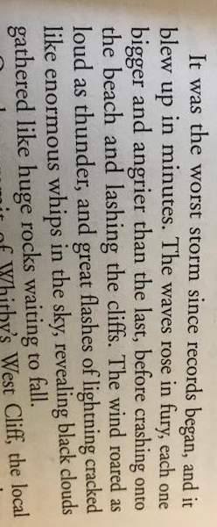
Underline the key phrases
Draw an image which represents the description. Annotate using the text.

